Management and delivery of water ecosystem services on the Lunan Water :
can the current Milldens weir gates help deliver improvements or
are other arrangements needed?

Discussion paper for Lunan Catchment Group meeting, 27 October 2016
Andy Vinten, James Hutton Institute

Introduction
The water ecosystem services issues in the Lunan Water catchment (eg. flooding and low flow mitigation; maintenance or improvement of endangered wetland ecology) and the hydraulics of the system d/s of Balgavies Loch (see Figure 1) have been described in a previous paper considered at the July 2016 meeting of Lunan Catchment Group (Vinten, 2016). The two key elements of water ecosystem services we are investigating are:
(a) Potential for generation of extra storage capacity in the Balgavies and Rescobie lochs and surrounding wetlands, to accommodate winter flood storage. This could be achieved by attaining a lower base level in the Lochs at the end of the dry summer/early autumn period.
(b) Potential for more timely delivery of suitable flows to downstream users of the Lunan Water at low flows. This could be achieved by storing of water in early summer in the Lochs so that the necessary supplies of water for maintaining ecological flows and protecting interests of marginal wetland ecology, irrigators etc. could be met.
While hydraulic and hydrological modelling of the system may be a useful medium term goal, in light of the complexity of the local system d/s of Balgavies Loch, we considered it useful to carry out empirical work to:
- obtain direct information about how the system would respond to changing management at low flows
- generate calibration data for modelling.
We have done this over the last 3 months by carrying out and analysing observations of water levels and discharge as we modified the positions of the weir gates at Milldens weir, downstream of Balgavies Loch.
A third key element of water ecosystem services to be considered is improved high flow management. This could be done through introduction of better hydraulic controls d/s of Balgavies Loch. Empirical evidence for this element needs to be obtained at medium/high flows later this autumn, but we can make some comment at this point.
Observations
Water levels and discharge as affected by weir gate position
Figure 2a shows water levels and discharge measurements in Balgavies Loch, upstream of Milldens weir and at the spillway into chapel mires during a series of Milldens weir gate position changes in July 2016. Water level in the loch at the start time was 59.50m and both the mill lade and the return gates were open. The recession rate of loch level was about 6mm/d. Discharge from the Loch was 124 L/s with 46 l/s of this passing through the chapel mires spillway and the rest through the return gate at the weir. When the return gate was closed there was a brief interlude in the recession but only for about 6 h. There was some decline in the combined flow across the chapel mires spillway and through the mill lade during the 2 day period when the return gate was closed. This could be because of a gradually declining hydraulic head along the mill lade, as this fills with water.
When the mill lade gate was also closed, there was an increase in head at the chapel mires spillway, and a small increase in discharge from 46 to 54 L/s, but no influence on the recession of loch levels, nor was there a change in recession when both gates were re-opened.
Figure 2b shows data collected near the end of another long dry period in Sept/Oct, when water level in the loch at the start time was 59.45m and the return gate was closed. The recession rate of loch level was about 3mm/d. Discharge from the Loch was 113 L/s with 72 l/s of this passing through the chapel mires spillway and the rest through the Mill lade. When the Mill lade was closed, the discharge through chapel mires spillway increased to 95 L/s. We left this arrangement overnight, with a view to checking if the recession rate of the Loch decreased the next day. However, on the next afternoon, the discharge out of the loch had increased to 156 L/s and at chapel mires spillway to 114 L/s. This was due to unexpected works carried out that morning (28th September) to remove vegetation from the outlet to the Loch. This vegetation clearance led to an increase in recession rate of the Loch to 10mm/d over the following 2 days. After a brief increase due to rainfall on 30/9-1/10, the recession returned to the pre-vegetation clearance rate of about 3mm/d for about 5 days. Closure of the return gate did not affect this for 2 days, but the loch level then reached a steady value of 59.42m. After 7 days of return gate closure, the discharge through chapel mires spillway had declined to 54 L/s. Opening the return gate at this point had no immediate effect on flow to chapel mires, and water levels in the loch then began to increase due to onset of more showery conditions after the long dry spell.
The minimum water level observed in Balgavies Loch over the period from March 2014 to the present is 59.35m in April 2015 (see Figure 3). This was after a long period when the Mildens return gate was open, but at the end of the winter period, when ground and surface water inputs are likely to be higher than in late summer. This is therefore unlikely to be the lowest loch water level attainable under current arrangements. So there would be benefit in obtaining observations of loch water level with the weir gates open all summer, as this would give a true measure of the potential to lower water levels. We note that the lowest water level observed by SWT’s Walrag at Balgavies Loch was 59.28m on 30 August 2003. If this were attained it would give additional storage (assuming both Rescobie and Balgavies Loch contribute) of about 100,000m³, relative to this year’s minimum level of 59.41m.
Water chemistry and protection of chapel mires from pollution
Note also in figure 3 the high soluble P concentrations in the discharge from Balgavies Loch at the end of summer/early autumn. It could be argued that these waters are not favourable for retention of the ecological status of the chapel mires, and would better be diverted as much as possible. For this reason, we investigated the sources of water contributing to the chapel mires. This was done by mapping the elevations of the water margins around Chapel Mires using a portable RTK-GPS system. Data were collected in May-July 2015 and again in Aug 2016. Figure 4 shows the mapped extent of wetted area in the chapel mires wetlands in May of 2015. The area is considerably larger than the open water area depicted on Master Map and amounts to a total of about 5 ha. Figure 5 shows the water levels plotted vs the North-South component of the co-ordinates in July 2015, for the small wetland (green symbols), the large wetland (purple symbols) and the inlet zone from the Lunan Water (blue symbols). In July, the Milldens weir gate was closed, and so levels in the inlet zone are high. However the levels in the large wetland are low, and levels in the small wetland are higher, so there is a large gradient from river to large wetland, and a small gradient into the small wetland at this time. Therefore there is potential for both wetlands to be receiving polluted river water. Note that the large wetland area is joined to the small wetland area by a culvert (bed level 59.14m) at the closest point at the North west of the small wetland area. This restriction protects the small wetland from surface flows from the river, at least in low flow conditions, or when the level of water in the large wetlands is <59.14m. This data set illustrates that there is potential for water level controls (both on the common lade section of the Lunan Water and at the culvert adjacent to the small wetland, to influence the input of unwanted additional nutrients and other pollutant species into these wetlands. It is noteable that the best areas for the key protected species such as Cowbane and Bogbean, are in the small wetland, which is much better protected from surface water inputs from the river.

Discussion
We can deduce from the above observations, that:
- At low water levels, short term opening/closing of the return gate when the mill lade gate is open has little immediate impact on discharge from the loch, because much of the flow is accommodated by the chapel mires spillway in any case. The short term effect of closing the return gate is to make water available to the Mill Lade (ie the function it was designed for).
- However, prolonged summer closure of the return gate may cause the loch water level to plateau at about 59.35m due to groundwater baseflow of about 50 L/s (the observed flow into chapel mires spillway in Oct 2016, with return gate closed and minimal flow in Balgavies Burn or Mill Lade).
- It is possible that the minimum loch level achievable could be a little lower than the recent minimum (April 2015) of 59.35m, if the Milldens return gate were left open all summer. However, agreement on this might be difficult to achieve, as the closure of the Milldens return gate in summer is currently common practice, to ensure (i) adequate flows to the chapel mires to maintain the wetlands in summer months, (ii) to supply water through the mill lade for cattle drinking water and potato irrigation, on occasion (iii) for amenity to the Milldens mill.
- By contrast, we observed that removal of vegetation at the outlet to the Loch had a large and immediate impact on discharge from the loch.
- We think it likely that even if the base level on the existing gates were lowered to increase the gradient out of the Loch, this would have a relatively small effect on discharge because water also spills into Chapel mires at these low flows. Only if the Milldens return gate were lowered sufficiently (ca 20cm, to < 58.9m base level - the approximate bed level of the spillway to chapel mires) would there be potential for spillage to chapel mires to be cut off and flow out of the lochs modified.
- At low loch water levels, with both gates open, most of the flow travels through the chapel mires spillway. In early summer, this is desirable, but later in summer and in early autumn it may be less desirable. These flows are of phosphate-rich water from the loch due to late summer/autumn loch stratification and sediment anoxia events, and are often rich in cyanobacterial blooms.
- At low flows, only when both gates are closed is there an immediate impact on the flow through chapel mires spillway (increased flows).
Implications for management:
- The current setup does not permit effective management to increase flood storage by lowering loch levels in late summer by changing Milldens return gate management.
- The current setup is not suitable for managed delivery of increased flows to downstream users (eg irrigators) at low flows, by temporary storage and release of water from the loch.
- By contrast, evidence from the vegetation clearance event in September is that significant, ecologically and economically valuable increases in downstream discharge could be achieved by modest control of water levels at the Loch outlet.
- The current set-up is suitable to influence flow of water to chapel mires in early summer, when loch levels are higher, to ensure adequate water is present in these wetlands over the summer, especially if the Mill lade can also be closed to enhance flow to chapel mires.
- The current set-up is not suitable to reduce flows to chapel mires spillway below the current minimum during late summer to prevent input of nutrient-rich waters.
- Physical lowering of the effective base level of the outlet could give significant (>10cm) additional flood storage and potential for release at low flows.
- A useful first step in this could be further clearance work at two specific locations: (i) the eel trap and associated concrete foundation at the outlet to Balgavies Loch could be removed. This acts as a trap for vegetation/branches which increase the base level of the loch. (ii) the removal of a section of aquatic vegetation (iris/water cress), probably associated with sediment accumulation, in a section of the common lade just downstream of the chapel mires spillway.
- Further steps could be engineered lowering of base levels either (i) at Balgavies Loch outlet and (ii) through a new tilting weir with lower base levels than the current Milldens weir (see map). This would be best upstream of the inlet of the Balgavies (Whirly) Burn, to avoid interference from the gravels and vegetation debris discharged by Balgavies Burn, and to increase the hydraulic gradient from the loch exit.

Putting observations in a wider context – drivers for changing management
The two main drivers for low flow management are to improve flood protection, and to ensure adequate water of suitable quality for aquatic ecology and for irrigation demand downstream of the lochs. Chapel Mires, the main wetland of ecological concern downstream of the lochs has an area of about 5ha. The area of ware and seed potatoes which could potentially need irrigation is around 2000ha. Thus even though these wetlands will need more “abstraction” water than the potatoes, their influence on demand for water at low flows is unlikely to be more than 1% of the total demand. Moreover, by supplying more water at low flows for irrigation, this water can pass through the chapel mires system, giving benefit. We can therefore consider the demand for water in terms of the frequency with which flows are lower than Q95, leading to potential restriction of irrigation by SEPA. Figure 6 shows the number of years out of 10 with which a given number of days when Q<Q95 occurs at the Kirkton Mill SEPA gauging station, in July and August, using records from 1981-2015. Also shown is the situation if an additional 30L/s of Balgavies loch water could be released for a month. So for example, 3 years in 10, the number of days in August with Q<Q95 would be reduced from 12 days to 3 days if the additional loch water were released. Vinten et al. (2015) estimated the economic benefit of unrestricted irrigation as £30k/year on average for the catchment), so this reduction in risk is a significant benefit.
Where could such a release be managed? We think that the best place to manage it would be at the outlet to Balgavies Loch. If a manually operated weir gate were set into the existing site of the outlet eel trap to a depth of 10cm, after removal of the eel trap and its foundations this would generate an additional potential release from storage across the 2 lochs (an area of 78ha) of 78,000 m³, which if released over 1 month, would generate an additional flow of 30 L/s. The gate would be removed at an agreed time in June-July, after the peak demand for wetland ecology in the upper catchment. The additional storage volume generated in the lochs would then be available as flood storage in the following winter. We are not yet in a position to quantify the impacts on flooding, but it is clear that a lowering of the levels in the loch by 10cm would provide a lower base from which the lochs would start receiving winter flows. In order to support this, we suggest that the riparian owners of the Milldens weir be requested not to close the weir return gate from beginning of August. This will also help to reduce the amount of nutrient rich water entering chapel mires in late summer/early autumn.
Apart from the generation of storage by releasing water at low flows, the main topic of this paper, a tilting weir could help directly with mitigating increasing water levels in the Lochs at high flows. Further empirical work on the impact of existing gate management on water levels at medium/high flows is planned for this autumn and this will be supported by hydraulic modelling. However, we note that during storm Frank in Dec 2015-Jan 2016, the water levels rose over 15 days at an average of about 60mm/d. A 1m wide weir, operating at a head loss of 0.5m can deliver a discharge of 605 L/s (using the website calculator for a contracted weir: http://irrigation.wsu.edu/Content/Calculators/Water-Measurements/Rectangular-Contracted-Weir.php). This is equivalent to 68 mm/d over the open water surface area of Rescobie and Balgavies Lochs. So operation of such a weir, in the period leading up to storm Frank, would have provided a very significant downward pressure on water levels in the lochs. Note that Q10 at Kirkton Mill is 3845 L/s, so such release, if made at flows that are not greater than Q10 flows, should not adversely effect downstream users.

Conclusions and Recommendations
The weight of evidence of the experiments measuring water head and flows as the gate positions are altered, which were done in summer 2016, is, on balance, that altered management of the existing gate arrangements cannot, on their own, deliver better ecosystem service provisioning. As some inexpensive actions are possible, and some further confirmatory monitoring of impacts of management under the current regime is desirable at high and low flows we recommend at this stage:
- Steps should be taken to implement item C above (outlet and lade clearance work – see Fig 1), while observations of hydraulic behaviour of the system at higher flows continue this winter;
- Agreement with the riparian owners be sought for (a) maintaining the weir gates in open position during late summer, next summer, to observe impacts on minimum loch water levels;
- Consent be sought from SNH and SEPA to remove the existing eel trap and its foundations at Balgavies Loch outlet, and, subject to advice from a structural engineer, lowering the outlet by 10cm. A 10cm high, manually operated weir gate to be installed in the gap created by this lowering of the outlet(with necessary consents). This gate to be closed from late winter (March) to mid-summer (Jun-Jul) and then opened to allow release to compensate low flow downstream, and to increase flood storage capacity of the lochs, by delaying rise in levels in autumn.
- A JHI led study be initiated to assess attitudes of SEPA, SNH and d/s farmers to improved management of low and high flows, readiness to pay for management and infrastructure, and views on how this should be governed.
- Subject to #4, provisional agreement with the riparian owners be sought for a tilting weir installation with base level minimum of 58.9m (the same as the base level for the spillage into chapel mires) upstream of Balgavies (Whirly) Burn, between the Common Lade and the Lunan Water (T.Sampson/J.Osborne). Begin consenting process.

References
Vinten, A.J.A. (2016). Draft proposal for installation of flexible hydraulic control through a tilting weir at outlet to Balgavies Loch, Lunan Water catchment, Angus. Paper tabled at first Lunan Catchment Group meeting, July 2016
Vinten, A.J.A. , Sample, J., Rear, L., Novo, P. and Halliday, M. (2015). Mitigation of low flows in an agricultural catchment in Eastern Scotland: can a combined ecological and economic case be made for investment in smart regulation of water flows? IWRA World Water Congress XV, Edinburgh, Scotland, UK. May 25th-29th 2015.

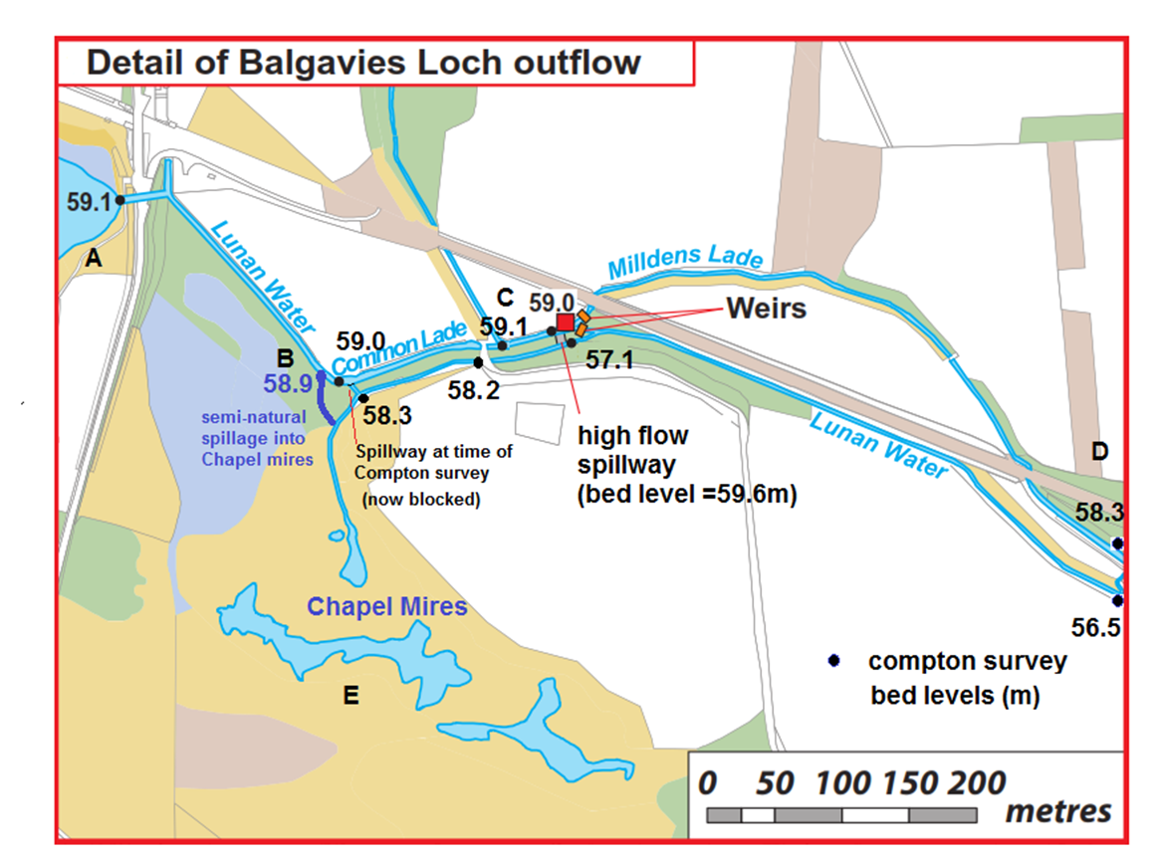
Mill lade gate and
Return flow gate

Potential site for
experimental
tilting weir

weir
Vegetation
clearance

Clearance of eel trap and foundations to lower bed level by 10cm; installation of manual 10cm deep weir gate

Figure 1. Details of outlet to Balgavies Loch, showing bed levels and current spillage zone into chapel mires upstream of Milldens weir gates (Mill Lade gate and return gate). Marked in red are proposed activities to be included in a potential CAR application.

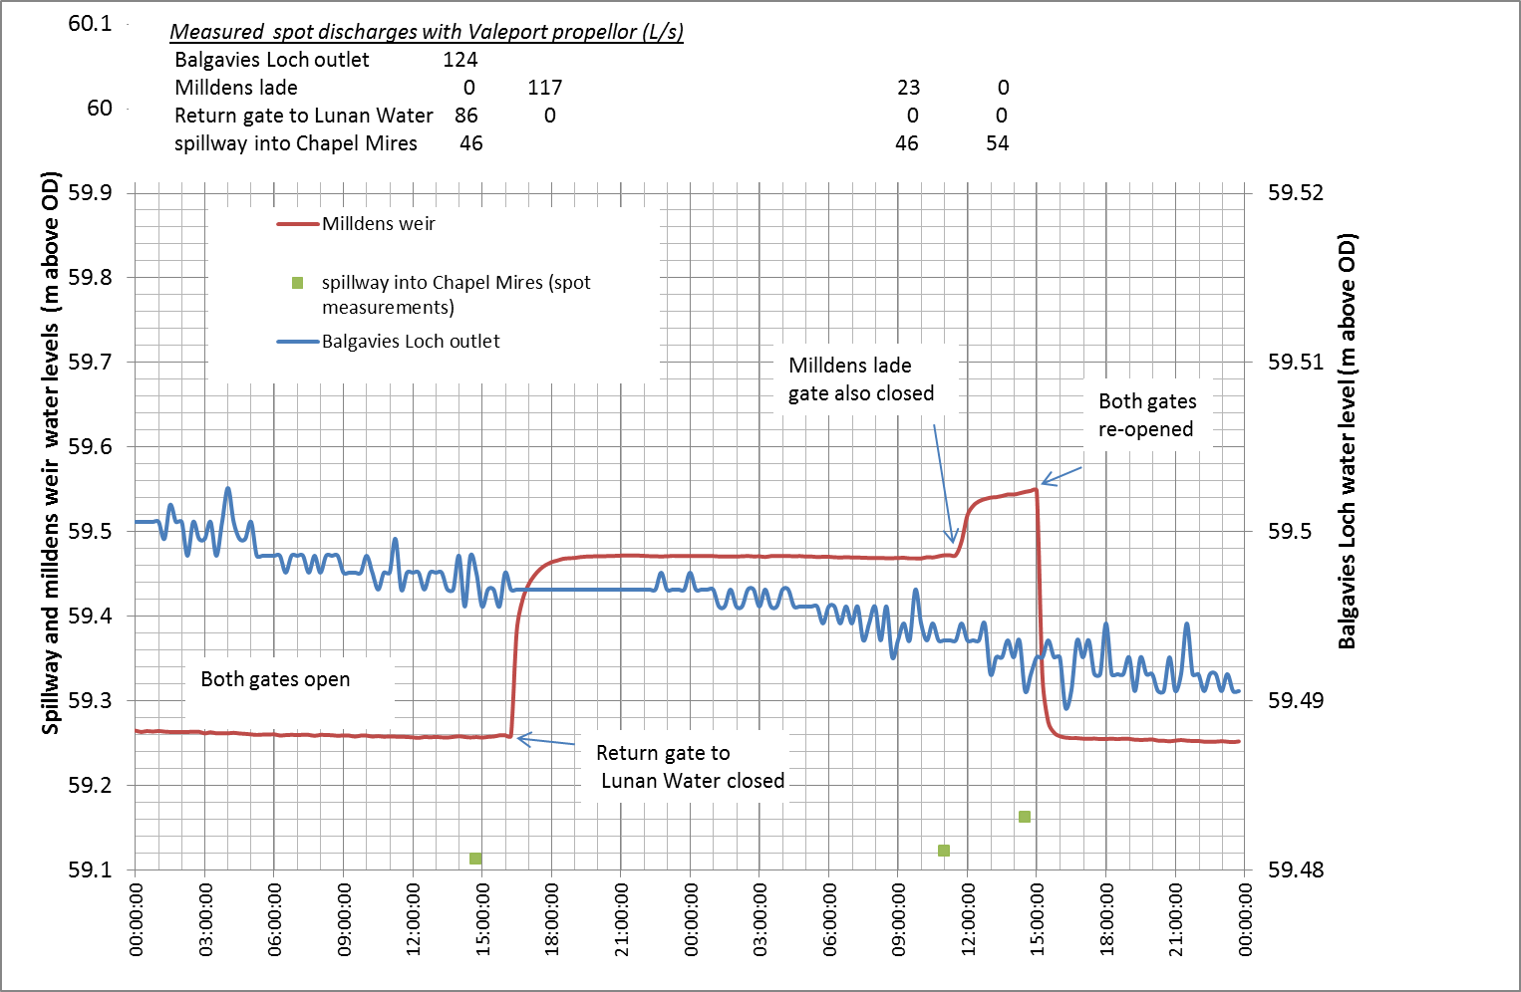
(a)

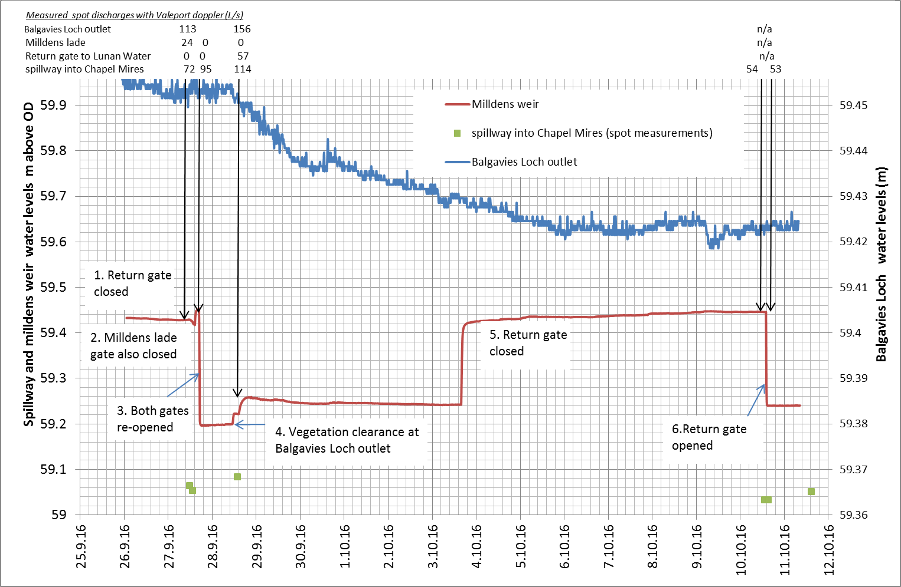
(b)

Figure 2. Details of water level measurements and flow estimates following weir gate changes. (a) using the Valeport propeller flow meter made at Balgavies Loch outlet, 26-27 July 2016. (b) using Valeport Doppler flow meter 27 September – 10 October 2016.

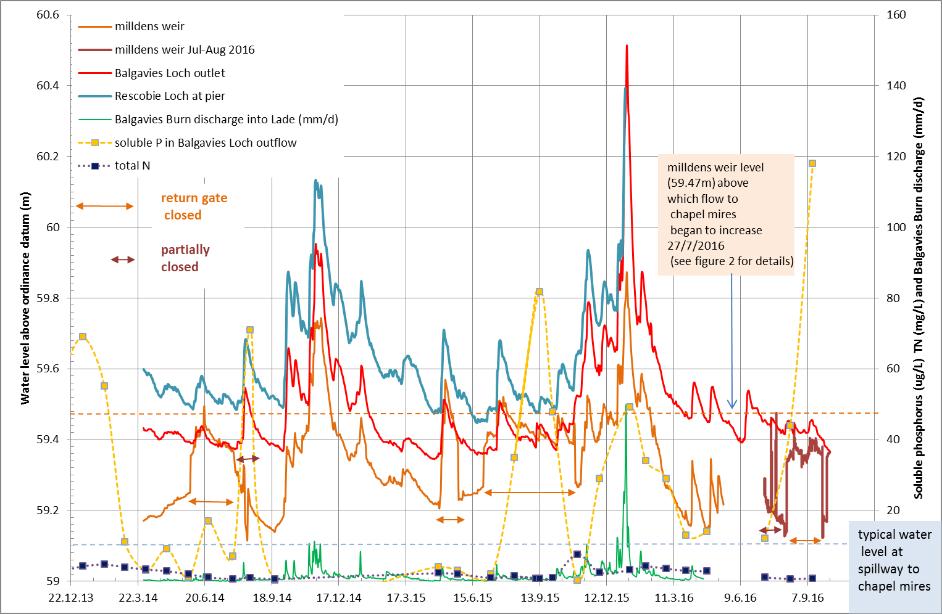

Figure 3. Water level data collected at Rescobie Loch outlet, Balgavies Loch inlet and Milldens Weir 2014-2016. Also shows discharge from Balgavies Burn, which flows into the system above mildens weir and the soluble P concentration in the outlet water from Balgavies Loch.

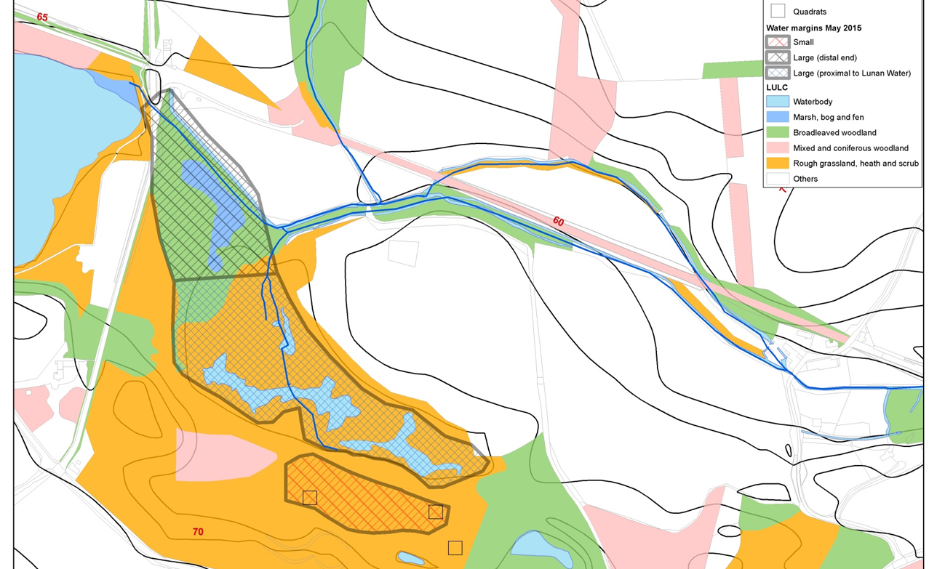
culvert

Figure 4. Extent of wetted area of the wetlands at Chapel Mires measured with RTK-GPS (mean surface level = 59.12m SD 0.14) May 2015 (mean surface level = 60.04m SD 0.08). Mean water levels at Milldens = 59.52m (return gate closed), Balgavies outlet= 59.51m and Rescobie Loch= 59.68m. The large wetland area is joined to the small wetland area by a culvert (bed level 59.14m) at the closest point at the North west of the small wetland area.

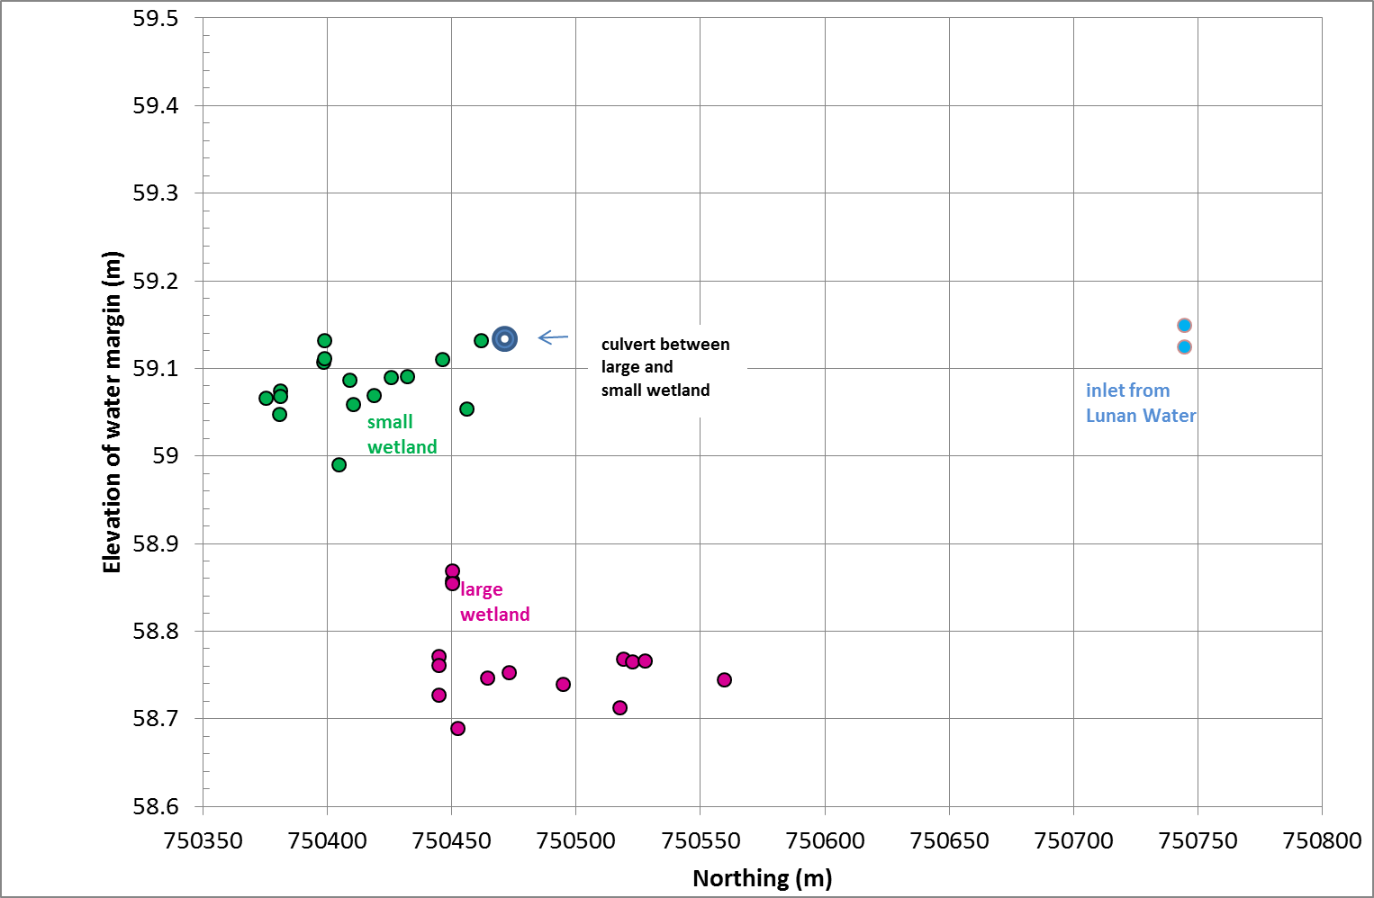

Figure 5. Water levels at margins of the small wetland, large wetland and inlet zone from the Lunan Water at chapel mires, measured in July 2015 (return gate closed).
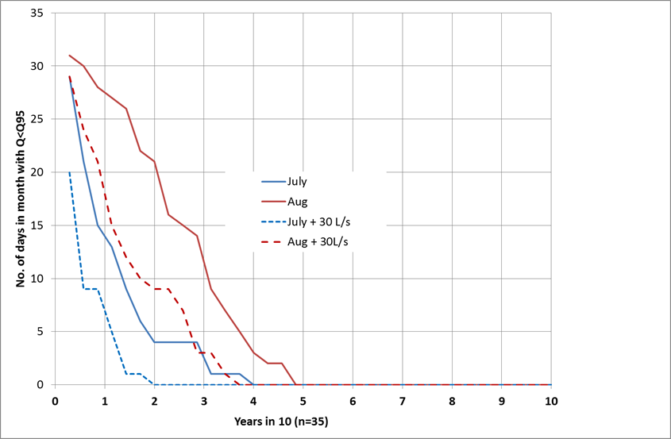
Figure 6. Number of years out of 10 with which a given number of days when Q<Q95 occurs at the Kirkton Mill SEPA gauging station, in July and August, using records from 1981-2015. Also shown is the situation if an additional 30L/s of Balgavies loch water could be released for a month.

