Progress report on “Water for all project” for Lunan Catchment Management October 2017.

Andy Vinten, Laure Kuhfuss, Orla Shortall, Ade Ibiyemi and Ina Pohle (James Hutton Institute), Iain Gunn, Mattie O’Hare and Justyna Olszewska (CEH, Edinburgh), Janice Corrigan (Angus Council).

- Introduction
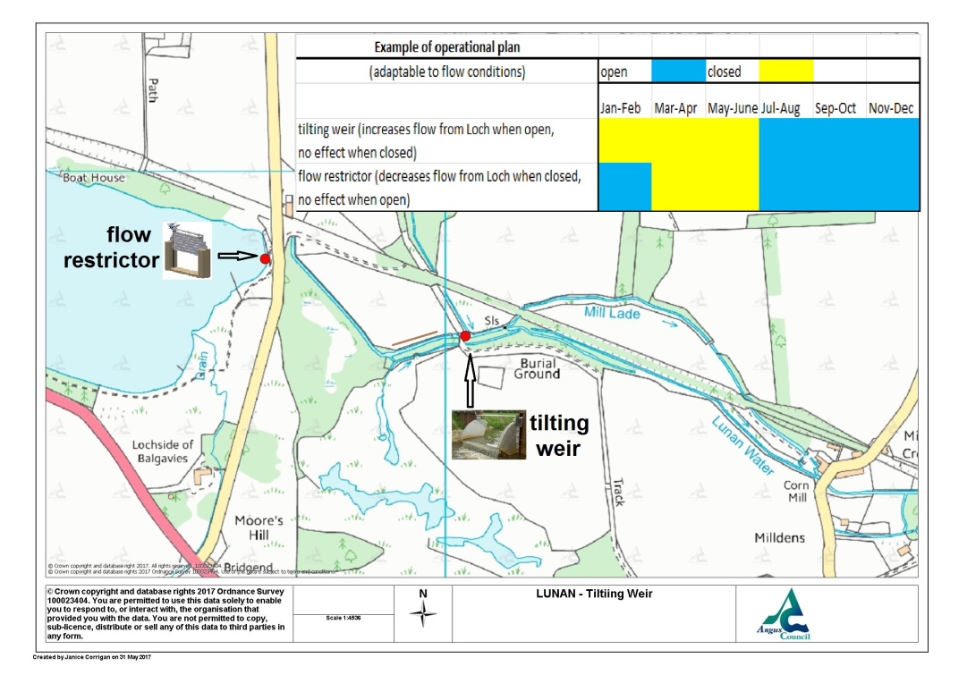
Upgrading of an existing hydraulic structure at the outlet to Balgavies Loch on the Lunan Water, Angus, Scotland, to allow more active management of water flows, eg. using a lateral tilting weir on the lade, has been proposed (Vinten et al., 2017) as a practical means to deliver improved water management in the catchment. In order to obtain consent for this proposal from both riparian owners and regulators, it is necessary to demonstrate benefit to the water environment across a range of pressures. In the Scottish Government funded “water for all” project (see http://www.hutton.ac.uk/research/projects/payments-ecosystem-services-lessons) we are focusing on 3 main areas of potential benefit – mitigation of flooding, mitigation of low flows and improvement in wetland ecology through management of nutrient and sediment loads to sensitive areas. It is necessary to satisfy requirements for a practical long term plan for governance, especially if a tilting weir is to be submitted for consent. There is a firm view among riparian farmers that dredging should be the first step in respect of alleviating flooding issues. It is also necessary to meet regulatory Agency requirements for intervention in the water environment. This report provides an update to the work described in Vinten et al (2017) with respect to (a) governance of improved water management (b) hydro-ecological characterisation, focused mainly on Chapel Mires, a marginal wetland downstream of Balgavies Loch that may benefit from improved water management and (c) assessment of impacts of proposed potential hydraulic structures and their management, focusing on the introduction of a tilting weir and a penning structure in the outlet area of Balgavies Loch and dredging of the lade to remove sediment. Figure 1 shows the location of these structures and an indicative management plan.

Figure 1. Potential location of proposed hydraulic structures at the outlet to Balgavies Loch, to provide improved water management. The line along the north shore of the lade shows the main proposed area for dredging.

Vinten, A., Wilkinson, M., Sample, J., Rear, L., Hoang-Cong, C. Novo, N. and Halliday, M. (2017b). Water level management in the upper Lunan Water, Angus, Scotland: threat or opportunity for improved delivery of water ecosystem services? http://www.hutton.ac.uk/sites/default/files/files/Lunan%20Water%20Managementv12.pdf

- Governance of improved water management

  - Social science research on governance and evaluation of water resources.
Understanding the social norms and values of stakeholders in the Lunan catchment is an important part of the research project as they influence which solutions can be implemented to solve water issues. The “water for all” project was proposed as a follow up to a round of interviews with stakeholders in a 2014 survey on attitudes to water management issues in the catchment. A summary of the results of these interviews is shown here.
Following on from this work, we recognised the need to gain practical insights into the likely level of interest in a water management scheme in the catchment and how this would be governed. The framework used for development of this social science work is presented in Figure 2.

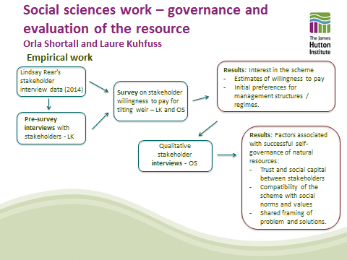
Figure 2. Framework for participatory social science work in the “Water for All” project.

A first step was to carry out scoping interviews, building on this prior work, to help frame a survey of willingness to pay for proposed measures, and of attitudes to governance. The slides used for these pre-survey interviews are available here. This led to an online and paper survey of stakeholders and residents in the catchment. An online version of this questionnaire at: www.linktosurvey.co.uk.
The objective of this survey was to measure quantitatively the support to the “water for all” project, which proposes the installation of a tilting weir and a flow restrictor at the outskirt of Balgavies loch for water management. The postal survey was sent to 60 farmers and 200 residents from the Lunan Water catchment. 5,000 leaflets were distributed in mailboxes and advertised in the catchment area to advertise the online version of the survey. 12 farmers and 61 residents responded, for a total of 73 responses, including 39 from the postal survey and 34 from the internet survey. 62 of the 73 respondents live on the catchment; the 11 remaining ones live in Angus. A preliminary summary of report findings is provided here.
Results highlight support to the project with 70% of respondents stating that the project should probably or definitely be implemented, but also identifies 2 types of concern: (1) About the project itself, with 25% of stated WTP being null, (2) About its governance, illustrated by the high level of protest zeros, due to either the lack of confidence that the project will be managed correctly under the proposed governance mechanism, a belief that others should fund it and/or a preference for another way of funding.
The preferred governance scenario appears to be that of a local government management, even though the differences in preferences need to be analysed further through (i) the analysis of open ended questions and (ii) in-depth qualitative interviews.
The next phase of this work is now underway, with participants in the survey being invited to contribute their knowledge and experience to the process of improving understanding of water management issues in the catchment by participating in an hour long interview. The interviews will take place between November 2017 and March 2018.
2.2 Feedback from potentially consenting parties for hydraulic structures at the outlet to Balgavies Loch
Running in parallel with the above social science survey work, the project has aimed to pursue consent for proposed water management structures, as it was anticipated that this would be a complex process, which would provide many lessons for implementation of such schemes. A paper (Appendix 1) was submitted to Balgavies Loch Management Committee in July 2017, including a draft consent application (available on request), prepared by Janice Corrigan of Angus Council Roads department and Andy Vinten of James Hutton Institute, for their comment. This committee includes riparian owners, representatives of the SWT reserve at Balgavies Loch, and is also attended by SNH. An extract of the minute of that meeting is provided in Appendix 2. The minute emphasised the need for further evidence that the proposed structures would be effective for management of water across the diverse range of water interests, and the need for more information on how such structures would be financed, managed and governed. The social science work described above will help to deliver evidence for the second of these concerns. With respect to the requirement for further evidence, our recent work has focused on further characterisation of the hydro-ecology of Chapel Mires, a wetland that could potentially benefit from improved water management, on more in-depth analysis of the hydraulics of the proposed system, and on approaches to forecasting the impact of management decisions on upstream and downstream hydrology.

- Characterisation of Hydro-ecology of wetlands in the area.
3.1 Mapping of mire and swamp classes for Chapel Mires
A draft map of National Vegetation Classes for Chapel Mires was prepared during summer 2017, with the help of SNH (Peter McPhail). This shows the prevalence of nutrient loving and sediment tolerating species, such as Phalaris arundinaceae (NVC S27a) and Spargimun erectum (NVC S14) close to the river, with more oligotrphic, Carex-rich classes such as NVC 28a, and transitional M28 Iris/Filipendula mire further away, where groundwater is likely to be a larger contributor to the overall water balance. In the central part of the wetlands a transitional mosaic of these communities occurs, as shown in Figure 3.
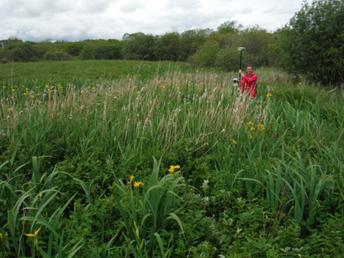
Figure 3. M28 Iris/Filipendula mire and a small area of S28 Phalaris mire in the central part of Chapel Mires wetland.
While such mosaics may be stable, there is a concern that current hydrological processes may be favouring the acceleratedl eutrophication of these Mires, through ingress of sediment and nutrients (see A. Scott Holaday, Dylan W. Schwilk, Elizabeth F. Waring, Hasitha Guvvala, Chelsea M. Griffin and O. Milo Lewis. Plasticity of nitrogen allocation in the leaves of the invasive wetland grass, Phalaris arundinacea and co-occurring Carex species determines the photosynthetic sensitivity to nitrogen availability. Journal of Plant Physiology, 2015, Volume 177, Page 20-29, and Werner KJ, Zedler JB (2002) How sedge meadow soils, microtopography, and vegetation respond to sedimentation. Wetlands 22:451–466). This concern is shared by SNH, who have observed such change in other parts of the wetlands, specifically the area of Clocksbriggs, to the west of Rescobie Loch. They have provided aerial photographic evidence of change in extent of Phalaris in this area since 1988 (McPhail, pers. Comm).
3.2 Analysis of mixing of water sources to Chapel Mires
The discharge, suspended sediment, N and P content of the waters leaving Balgavies Loch vary strongly through the year and our hypothesis is that it may be possible to reduce the ingress of such eutrophying waters into the Chapel Mires by management of a new weir with greater capacity for water level control (or by improved management of the existing structures). Estimation of the current contribution of the water flowing from Balgavies Loch along the common lade into the Chapel Mires is key to assessing this. To make this estimation we have employed end-member mixing analysis (EMMA) methods similar to those outlined by Christopherson and Hooper (1992) and Hooper (2016). The potential end members that we considered initially were spillage from the common lade of the Lunan Water, rainfall, local groundwater (as indicated by the ponds in woodland adjacent to Chapel Mires and runoff from the road and farmland to the south west of the area. Figure 4 shows an example of such mixing analysis for water samples taken in May to July 2017. Further analysis of the available data from 2015-2017 suggests that the large pond in the middle of Chapel Mires has a 70-80% contribution from river water, while the large pond further south has only a 40-50% contribution from river water. The contribution over river water to the area of oligotrophic Carex rich S27a wetland in the south of the chapel mires is <10%, but there is a significant input from the road (NaCl) into the western part of this area. This quantitative data thus confirms the vegetational data which suggests a transitional fen that may be vulnerable to addition of nutrient and sediment water from the river.

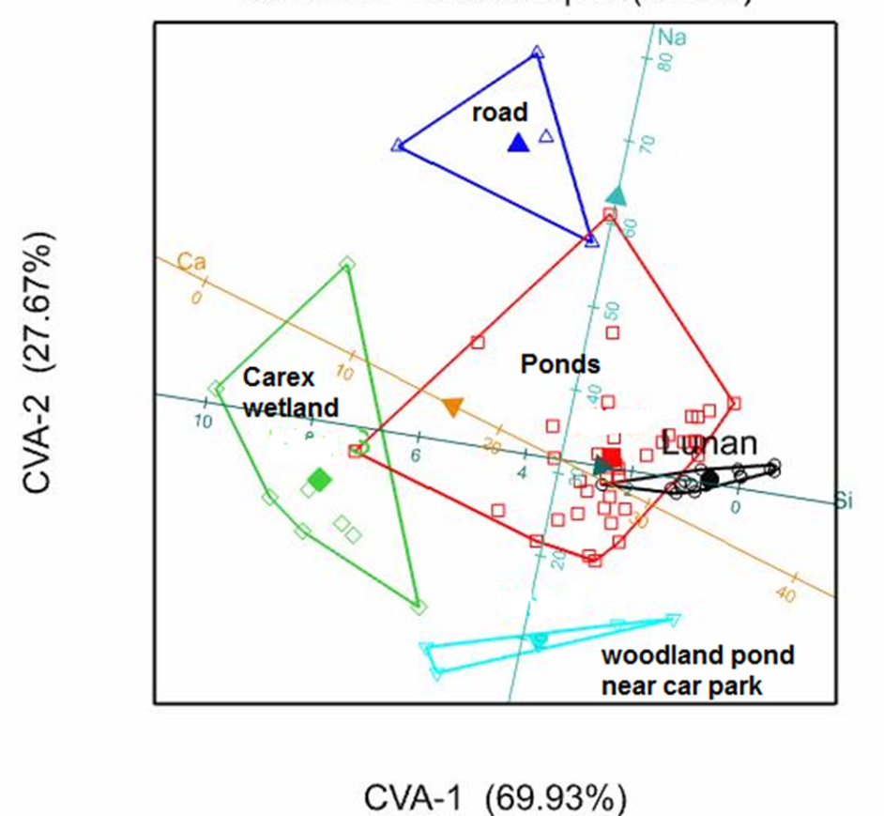
Figure 4. Water chemistry bi-plot for samples taken in and around chapel mires during May-June 2017.

North

More information on this analysis is available here. Note that the area of Carex wetland is partially protected at low water levels by a culvert (see figure 1), but not at high water levels. A rule base could be developed, using this mixing information and knowledge of how tilting weir management impacts the distribution of flows between the common lade and the spillway into Chapel Mires, to reduce inputs of nutrient (N and P) rich water into the wetlands.

3.3 Survey of aquatic plants in inlet pond, Pond 1 (Western pond) and pond 2 (Eastern pond) in Chapel Mires by Iain Gunn, Mattie O’Hare and Justyna Olszewska (CEH, Edinburgh).
The full text of this report is available here. Ponds 1 (i.e., the easternmost pond) and 2 (i.e., the largest and westernmost pond) were surveyed from an inflatable boat by means of visual assessment supplemented by regular sampling of the submerged macrophyte communities by use of a double-headed rake. This took place on September 11-12th 2017. The macrophytes in the Inlet Pond (i.e., the northernmost pond) and the Inlet were sampled from the bank using throws of the double-headed rake. There were no previous aquatic macrophyte data available to compare with. Pond 2 was the largest and most diverse water body in the Chapel Mires site with eight aquatic macrophytes species recorded; Ceratophyllum demersum, Elodea canadensis, Lemna minor, L. trisulca, Nuphar lutea, Potamogeton obtusifolius, P. pusillus and Utricularia vulgaris agg. (Figure 5).
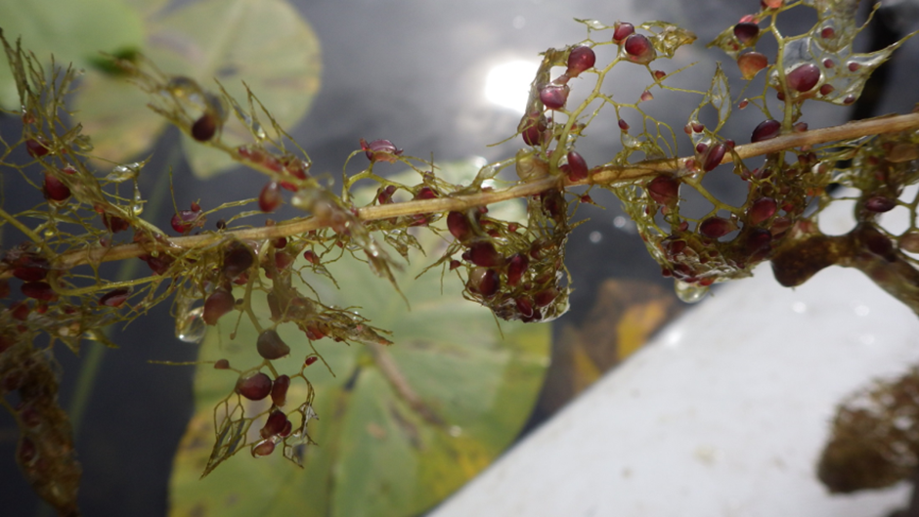
Figure 5. Utricularia vulgaris agg. collected from Pond 1

The majority were characteristic eutrophic species (all of which have been recorded in Balgavies Loch in recent years) although the presence of Utricularia vulgaris agg. indicated more nutrient poor conditions (as did the presence of emergents such as Carex rostrata and Menyanthes trifoliata). The western half of Pond 2 was dominated by the non-native Elodea canadensis while the eastern half was co-dominated by both Elodea and Ceratophyllum demersum. Pond 1 had a smaller surface area but a greater water depth than Pond 2 but lacked the two Potamogeton species and Elodea canadensis was rare. However, in the Inlet pond and the sampled section of the Inlet from the Lunan Water, Elodea was the dominant submerged plant species. Unlike Rescobie and Balgavies Lochs, there was no evidence of cyanobacterial blooms in any of the sampled water bodies in the Chapel Mires site and water clarity was excellent with Secchi Disc readings of 2.20 recorded in Pond 1. Evidence of this better water quality was reflected in the lower PLEX scores calculated for Pond 2 and the other sampled waterbodies in the Chapel Mire site, compared with the PLEX scores recorded in the recent surveys of Rescobie and Balgavies Lochs (see Tables 1-3).
It has been suggested that Phalaris arundinacea is invasive at the site. While it and Sparganium erectum are tolerant of more fertile conditions, both species are found in a very wide range of conditions. P. arundinacea, in particular, is nearly ubiquitous along British river and lake margins, and is only absent at the most oligotrophic of sites (Preston and Croft, 1997). It should be considered a natural element of the assemblage at Chapel Mires and not thought as an aggressive invasive species. Any reduction in nutrient inputs may disadvantage S. erectum but the response from P. arundinacea is likely to be more muted. It should be noted that fine sediment builds up around S. erectum and is likely to hold nutrients. Therefore, any response to a reduction in nutrient inputs will be tempered by the internal supply from deposited fines. The authors of this report conclude that there is likely to be little or no negative impact to the qualifying interests from the introduction of a tilting weir and any significant reduction in nutrients to the systems should be considered as potentially beneficial.
3.4 Assessment of impact of proposed water level changes on Balgavies Loch and Rescobie Loch.

- Hydraulic modelling of the Lunan Water reach downstream of Balgavies Loch (Andy Vinten, Ade Ibiyemi).
The goal of this work is to determine the impact of introducing a modified water management regime to the outlet of Balgavies Loch, for example by using a tilting weir on the common lade on (i) upstream water levels and (ii) the distribution of flow and sediment between chapel mires wetland and the Lunan Water downstream of the lade system. We also want to assess the impact of dredging sediment from the lade system, in conjunction with modified water management. Impact of a penning structure at the outlet to Balgavies for management of low flows has not been considered further at this stage.
- Preliminary ID hydraulic modelling using HECRAS of the lade d/s of Balgavies suggests a tilting weir could be useful in delivering reduction of flow to Chapel Mires at times when the Lunan Water carries a large burden of sediment and nutrients.
- A tilting weir appears to be less useful for delivering reduction in water levels upstream.To confirm this, 2D modelling which includes upstream standing water bodies (Balgavies Loch and Chapel Mires ponds) and Balgavies Burn is needed.
- There is a clear beneficial impact of dredging the mill lade upstream of Milldens weir.
- To maintain the benefit of the dredging through time, a management scheme needs to consider how to deal with the further ingress of sediment. A tilting weir, or other hydraulic structure to promote flushing, is likely to be beneficial.
- We recommend that a separate consent application to deliver dredging of the mill lade be drawn up, while the above hydraulic modelling is completed.
- There is minor indication of a backwater effect of opening the return gate at Milldens weir, and for this reason, it may be better to maintain both the return gate and the gate to Milldens lade in closed position during winter.
- To improve our modelling of the actual channels, a detailed survey of the channel cross sections for both the lade and Lunan Water is recommended, to supplement existing data.
For more information, see paper A.Interim report on hydraulics modelling
- Survey of attitudes to proposed water management changes in the Lunan Water (Laure Kuhfuss, Orla Shortall)
The objective of this survey is to measure quantitatively the support to the “water for all” project, which proposes the installation of a tilting weir and a flow restrictor at the outskirt of Balgavies loch for water management. The postal survey was sent to 60 farmers and 200 residents from the Lunan Water catchment. 5,000 leaflets were distributed in mailboxes and advertised in the catchment area to advertise the online version of the survey. 12 farmers and 61 residents responded, for a total of 73 responses, including 39 from the postal survey and 34 from the internet survey. 62 of the 73 respondents live on the catchment; the 11 remaining ones live in Angus. Preliminary results will be presented at the Lunan Catchment Management Group meeting on 24th October.
For more information see paper B. flier on Water management issues in the Lunan Water.
Also on webpage http://www.hutton.ac.uk/research/projects/payments-ecosystem-services-lessons
- Student project on analysis of mixing of Lunan Water with chapel mires wetlands (Marjorie Gabriel, Andy Vinten).
This shows a gradient of mixing of Lunan Water with other sources (road runoff, groundwater) in the composition of the water in the Chapel Mires wetlands from north to south. This helps to explain the reasons for the transitional nature of the wetlands, with more oligotrophic species present in the southern part, and more eutrophic species in the northern part, adjacent to the river. It also confirms that modifying water management to reduce flow of nutrients and sediment to the wetland might be beneficial to conserving the more oligotrophic elements of the system.
For more information, see paper C. Could managing water levels of Lunan Water.....

- CEH report of aquatic plants and assessment of impact of water management changes on Chapel Mires, Balgavies and Rescobie Lochs. (Iain Gunn, Matthew O’Hare)
This confirms the transitional nature of the chapel mires open water bodies associated with the chapel mires wetland and that changes in nutrient loads and water level management would be likely to “switch the balance in dominance between the communities present”. It also states that proposed changes to water levels in the Lochs are likely to have relatively minor impacts on aquatic plant communities. The strongest of any impacts are likely to be on the plants inhabiting the upper littoral. Potamogeton filiformis, a nationally scarce species not recorded since 2007, is the main species of concern in this respect.
For more information, see paper D. Review of aquatic ecology….

- Update on CEH work on modelling water quality at the outlet to Balgavies Loch (Linda May, Bryan Spears).

- Whole catchment hydrological model (Ina Pohle)
The objectives of this work are: (i) to generate an analysis of the changes to flows in the Lunan Water, and hence risk of low flow abstraction restriction and flooding, as a result of changes in water management (ii) to provide a management tool, which forecasts the changes in flows and water levels as a function of water management, on a weekly timescale. A methodology for this has now been developed, which can make use of changes in the stage-discharge relationship at the outlet to Balgavies loch predicted by the hydraulic modelling (item (a)).
For more information, see http://www.hutton.ac.uk/research/projects/payments-ecosystem-services-lessons
- We have commissioned detailed drawings for two rural sustainable drainage systems (SUDS) at two sites on the fringes of Fonah Bog. These are being prepared by Stewart Moir of Moir Environmental, the lead author in the recently published rural SUDS manual. We understand that the approval of these structures will be dependent on the development of sediment management plans by land users contributing to the sediment runoff. SNH have a funding stream to develop these plans with land users

Andy Vinten
19.10.2017

Appendix 2.
Extract of minute from Balgavies Loch Committee
5. Lunan catchment issues :
a) Suds : no change since previous minute RP
b) Tilting weir : As landowner’s consent is required this may not proceed.
After discussion it was concluded that stakeholders were not convinced that the proposals were worthwhile and that the SWT should not support the proposal on the basis of the information currently provided.
Watching brief to continue RP
The Committee also rejected Andy Vinten’s proposal to install a flow restrictor or penning structure at the outlet of Balgavies loch. (Flow restriction in late spring/early summer would store water in both lochs for irrigation in July/August). As landowner, SWT consent is crucial if this were to go ahead.
The consent of landowners, Tom Sampson and James Osborne, is required for the tilting weir in Chapel Mires- this was refused.
It was also agreed that what was really needed was a “whole catchment” approach to the Lunan issues.

Stakeholders’ norms and values about farming and the environment
Understanding the social norms and values of stakeholders in the Lunan catchment is an important part of the research project as they influence which solutions can be implemented to solve water issues. Stakeholders described the following norms and values concerning farming and the environment as part of their decision making.
Farming norms | Environmental norms
Production oriented. Changes to water management shouldn’t conflict with farmers’ right to make a living off the land. | Polluter pays. Those causing environmental problems should address them, such as farmers installing sediment fences.
Custodians of the land. Farmers have been taking care of the land for hundreds of years and should be allowed to do so. | The environment needs spokespeople. Environmental considerations and resources without economic benefits need to be represented in decision making.
Sovereignty. Farmers own the resources on their land and should be allowed to use them as is necessary for production. | Farming and the environment not mutually exclusive. Solutions to environmental issues need not impact farming.
Environmentally minded. Some farmers value the flora and fauna created by non-productive land for its own sake. | Environmental issues and farming are compatible in the long run. Farmers have an interest in protecting their environment such as stopping soil erosion.
Undervalued in society. Farming is little understood and undervalued by society. Food is cheap making it difficult for farmers to balance environmental and production aims. | Access to resources does not mean ownership. Water resources are part of a bigger system with wide impacts, meaning people cannot exploit resources on their land as they wish.
Intensification requires more oversight.
Agriculture has intensified in recent decade with more environmentally disruptive practices. This requires more oversight.
Stakeholder relationships and water management
Factors within stakeholder relationships which were seen as preventing successful water management included:
- Lack of communication on stakeholders’ needs, problems, duties and the actions they will take which might affect others.
- Lack of resources to facilitate communication.
- Confusion over the water management actions land owners are and are not allowed to carry out.
- A perception of a power imbalance between stakeholders leading to lack of communication, unwillingness to engage and inaction.
- Lack of data about water management practices such as farmers’ abstraction levels which would lead to a better understanding of the issues in the catchment.
Factors which were seen as improving stakeholder relationship and successful water management included:
- Effective communication between stakeholders about their needs, problems and responsibilities.
- A “softly softly” approach to management that would give land owners’ sovereignty over their land and allow them solve problems collectively, while respecting certain rules.
- More accurate data which would allow for a better understanding of the current situation and what needs to change.
- Monetary incentives could bring about changes in some cases.
- Change would also require concessions to be made from several parties to fulfill the needs and priorities of those undertaking the change.
If you have any questions please do not hesitate to contact the researchers: Orla Shortall: orla.shortall@hutton.ac.uk, 01224395302; Andy Vinten: andy.vinten@hutton.ac.uk, 0844 928 5428; or Laure Kuhfuss laure.kuhfuss@hutton.ac.uk 01224 39 5404.

Water management issues in the Lunan water:
Results from 2014 stakeholder interviews
Orla Shortall, Lindsay Rear, Andy Vinten, Paula Novo and Laure Kuhfuss
James Hutton Institute, Aberdeen.
The Lunan water catchment has faced flooding and water quality issues in recent years. Interviews were carried out in the summer of 2014 with 16 stakeholders as part of ongoing research at the James Hutton institute. Stakeholders included farmers, land owners, representatives from government and non-governmental organisations. Interviews explored views on water issues in the catchment, causes and potential solutions as well as the potential for a scheme to pay stakeholders for water benefits in the catchment.
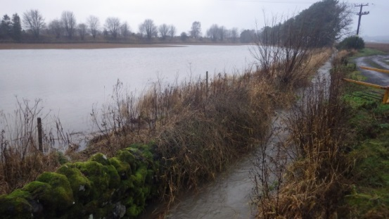

Water management issues, causes and potential solutions according to stakeholders
Different problems with different causes and potential solutions were identified by stakeholders.
Water issue | Why is it a problem? | Cause 1 | Cause 2 | Cause 3 | Cause 4 | Desired solution 1 | Desired solution 2
Flooding - farmland, houses, roads. | Damage to house, crops, farmland, infrastructure. | More rain and more extreme rain events, potentially due to climate change. | Waterways blocked by debris and silt. Less freedom for land managers to dredge and clear waterways than in the past. | Runoff from fields raising water levels. | Dredging can cause flooding downstream. | More freedom to dredge and clear water ways.  Or, more holistic water management rather than piecemeal dredging. | Sediment fences and other measures on farms to reduce loss of sediment.
Loss of topsoil on farms. | Farmers lose a valuable resource – soil. Soil runoff into water courses causes pollution and exacerbates flooding problems. | Flooding washes soil away. | Potato farming – removal of stones from fields and creation of furrows leads to soil runoff. | Potato contracting means the people growing the potatoes have less of a long term interest in taking care of the land. |  | Careful potato cultivation practices – e.g. creating furrows at right angles to slopes to reduce runoff. | Installing sediment fences to minimise runoff.
Water shortages | Less water available for irrigation in the summer – likely to be a bigger problem in future. Damaging for the river ecology. | Weather variability – dry summers mean lower water levels and also more demand for irrigation. | Lack of holding ponds due to expense and lack of available land area. |  |  | Collective management - farmers decide among themselves how to allocate abstraction rights to limit stress on the river. | Creation of water storage ponds/damming water for retention.
Threats to catchment ecology. | The catchment has valuable wetland habitats such as Chapel Mires and Fonah bog. The Scottish Government is working to improve the ecological status of catchments. Recreational activities such as fishing are threatened by poor ecology. | Pollution –eutrophication is damaging to the flora and fauna in water courses and a real threat to valuable wetland habitats at Chapel Mires and Fonah Bog. | Heavy duty dredging and clearance of waterways damages river ecology. | Fluctuating water levels – flooding and water shortages, could damage the delicate ecology in wetlands. |  | Changes to farming practices. Installing sediment fences to minimise runoff and so eutrophication. And use of precision agriculture technologies so less fertiliser is applied. | Light touch, targeted and holistic waterway clearance and dredging. E.g. clearance by hand rather than with machines. Dredging smaller areas.
Not enough data on the catchment. | Makes management of the catchment more difficult. Reliable data is needed to make claims about the catchment and propose solutions. | Abstraction rates not being returned by farmers because they are difficult to calculate, seen as time consuming and unnecessary. |  |  |  | Farmers to return abstraction licences. | Provide farmers with water metres to monitor abstraction rates.

As you can see in the table, certain causes or solutions put forward by stakeholders were somewhat contradictory, particularly around the role of dredging in the catchment. The research did not aim to judge which perspectives were “right” but rather highlight and explore the complexity in how issues in the Lunan water catchment are viewed.

