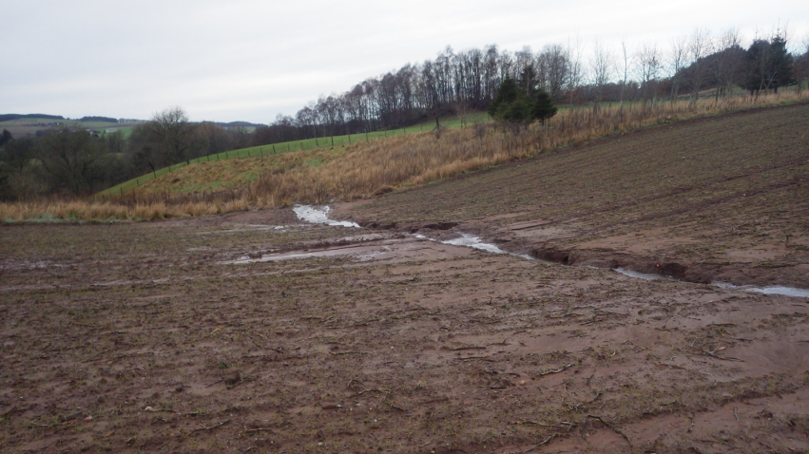
SEDIMENT AND WATER MANAGEMENT IN THE LUNAN WATER

Funded by Scottish Government Environmental Co-operation Action Fund

The aim is to deliver a farm and water body-based integrated catchment plan for cost:effective sediment and water management . This will make use of the multiple benefits associated with well targeted AECS Options, Water Environment Fund measures, privately funded measures and SG funded research project contributions, as well as helping to ensure regulatory requirements, such as GBRs are met. This will be done using a collaborative approach with local farmers and other stakeholders. The main priority with respect to targeted AECS funded measures is improved water quality by sediment trapping, but benefits in keeping with several other priorities, especially flood management, and other benefits, would also ensue. An overview flow chart for the project is given below.
People:
Carol Littlewood, a Farm Conservation Adviser with over 13 years’ experience, with facilitate the collaborative approach to the project, with Andy Vinten of JHI as project lead. Carol's work will be supported by expert input from others:
Richard Lockett (Lockett Environmental)- acting as expert on sediment and water auditing, bringing experience on rural SUDS implementation from Loch Leven and elsewhere.
Andy Vinten (James Hutton Institute) has run annual catchment science updates for farmers and local stakeholders in the Lunan catchment to help promote GBR uptake, develop novel measures for sediment and water management and report on RESAS funded monitoring.
Stuart Moir (Moir Environmental) has wide experience of delivering sustainable drainage solutions, and is involved with preparation of the CREW funded guidance document for rural SUDS.

SEDIMENT AND WATER MANAGEMENT IN THE LUNAN WATER
2016-2020

Strategic meeting of project facilitator and JHI with local agencies
SEPA, SWT, SRUC Forfar, NFUS, ERFT, SNH,Angus Council
to highlight project aims and identify (1)hotspots for sediment and water management (2) key farmers (3) Contacts network

2017 Lunan/Vinny
Draft strategic plan

Farms for sediment and water audits identified

Farm factsheets, field visits and national reporting

rSUDS outlines leading to
2017 AECS applications
Lunan Water

2018 (Lunan) and 2019 (Vinny)
Delivery and monitoring of successful AECS plans and other measures

2018 Lunan/Vinny
Revised strategic plan

Networking and publicity

Farmer engagement meeting

rSUDS outlines leading to
2018 AECS applications
Vinny Water
2017/8 Vinny visits
10 farms leading to
6 draft sediment and water plans

2016/7 Lunan visits
10 farms leading to
6 draft sediment and water plans

