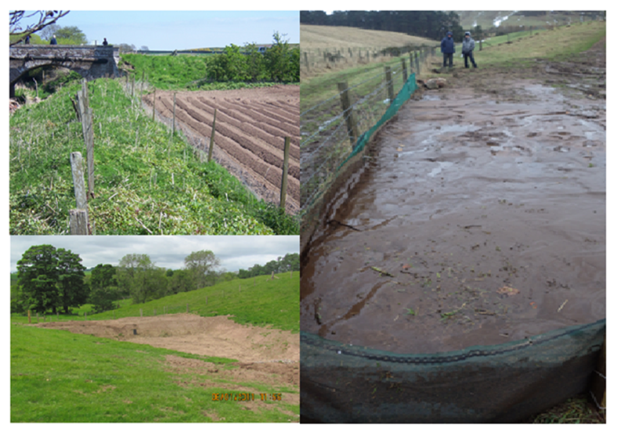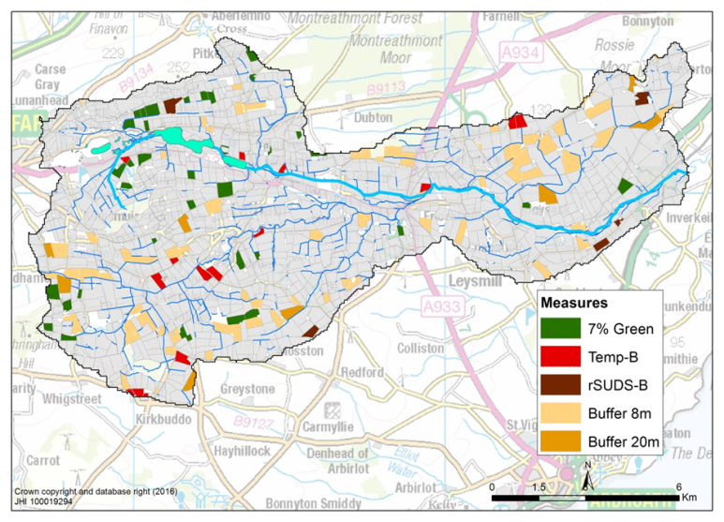

**Purpose**

SUDZ-xy is a tool for cost-effectiveness analysis of field scale sediment-bound phosphorus mitigation measures. The tool can be used to carry out spatial (xy) and temporal (Z) targeting of mitigation measures (SUstainable Drainage) at field scale across a catchment, to deliver target reductions in export of sediment or sediment bound P to surface water.

**Input requirements**

<INPUT FIELD DATA>

Annual IACS crop data for each field in a catchment and each year (default 5 years of data) : field IDs, field areas, perimeters,average slope and connectivity with water.

<INPUT MEASURES DATA>

Choice of measures to be considered (Buffer strips of 2-20m width, SUDS-wetlands, SUDS-sediment bunds, sediment fences or other temporary barriers, targeted set-aside or other greening measures);

Orientation of lowest corner of fields relative to contours; installation costs; post-harvest management in high risk years; area occupied by SUDS; discount rates and crop gross margins.

**Outputs**

Cost-optimized choice of measures across a catchment to deliver target reduction in sediment-bound P loads; cost-curve relating costs and mitigation of P loads; potential to link to GIS display of optimized measures on field-by-field basis across a catchment.

**Process**

The initial input data goes into an excel workbook. Cost-effectiveness analysis is carried out on an excel output file using PuLP (https://github.com/coin-or/pulp), a linear programming module for Python. The problem was formulated as a Binary Linear Program, which was used to minimise the cost for a specified effectiveness, subject to the condition that each field could have a maximum of only one measure.

**Authors (contact:** [**andy.Vinten@hutton.ac.uk**](mailto:andy.Vinten@hutton.ac.uk) **or** [**ade.ibiyemi@hutton.ac.uk**](mailto:ade.ibiyemi@hutton.ac.uk) **for access)**

Andy Vinten, James Sample, Ade Ibiyemi and Marc Stutter (James Hutton Institute). version 1.1

**Publication**

<http://dx.doi.org/10.1016/j.scitotenv.2017.02.034>

**SUDZ-xy**

 

**Acknowledgement**

This work was funded by the Scottish Government

Rural Environment and Rural Affairs (RESAS) Department as part of the Waters Theme within their Strategic Research Programmes, 2011-2016 and 2016-2021