Vector tile two-minute introduction
Why might you be interested in vector tiles? Your work involves data with a location attribute i.e. spatial data. You are interested in spatial data representing specific features on the Earth’s surface; vector data include points e.g. monitoring locations, lines e.g. a river network, and/or polygons (enclosed areas) e.g. a woodland. You use desktop GIS software e.g. Esri’s, or free and open-source alternatives e.g. QGIS to store and analyse spatial data, you may manipulate spatial data using programming languages like Python or R, and/or you may be interested in the production and use of web/mobile apps that use spatial data. You may already be familiar (or even be expert) in the use and creation of vector tiles. You may not even realise that you have been using vector tiles in your Esri GIS basemaps (a layer with geographic information that provides the context for additional layers) or on web/mobile apps you use.
What are vector tiles and why might they be of use to you? Vector tiles are increasingly being used to provide vector data. They are popular for delivering styled web maps, as they have smaller data requirements than raster (image) tiles and they can easily be customised e.g. you can change the colour of a feature. As you zoom into a map on an app (with vector tiles), then layers of tiles are added with different levels of detail e.g. finer representation of boundaries (illustrated in Figure 1).
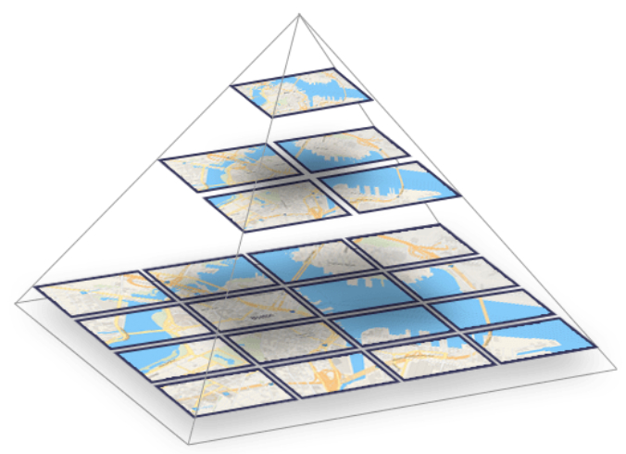
Figure 1. Vector tiles for different zoom levels (image from Maptiler)
MapBox have been creating and using vector tiles for about ten years, more recently they became available in Esri’s JavaScript API 4.0 and related Smart Mapping (2016), in desktop ArcGIS Pro (2016), and are now natively supported in desktop QGIS (2020). The UK Ordnance Survey (OS) trialled vector tiles in 2018 and released their OS Open Zoomstack product in 2019.
Here are examples of vector tile use cases (please let kit.macleod@hutton.ac.uk know of other use cases, or what you would like further information on): you use Esri ArcGIS Pro (or ArcGIS online) and are interested in vector basemaps and/or creating vector tile packages; you use QGIS desktop GIS software; and/or you are involved in developing web/mobile apps using basemaps from providers including Esri and Mapbox, use tools to style vector tiles e.g. Mapbox Studio, and/or are interested in how to use them.

This work was funded by the Macaulay Development Trust.
https://www.maptiler.com/news/2019/02/what-are-vector-tiles-and-why-you-should-care/
https://docs.mapbox.com/vector-tiles/reference/
https://www.esri.com/arcgis-blog/products/announcements/announcements/its-here-arcgis-api-for-javascript-4-0-released/
https://www.esri.com/arcgis-blog/products/arcgis-online/mapping/how-to-smart-map-in-3-easy-steps/
https://www.esri.com/arcgis-blog/products/mapping/mapping/vector-tiles-preview/
https://www.lutraconsulting.co.uk/crowdfunding/vectortile-qgis/
https://www.ordnancesurvey.co.uk/business-government/products/open-zoomstack
https://www.esri.com/arcgis-blog/?s=#&tag=vector-basemaps
https://pro.arcgis.com/en/pro-app/help/sharing/overview/vector-tile-package.htm
https://www.lutraconsulting.co.uk/blog/2020/06/10/vectortiles-part1/
https://www.arcgis.com/home/group.html?id=30de8da907d240a0bccd5ad3ff25ef4a&view=list&showFilters=true#content
https://docs.mapbox.com/vector-tiles/reference/
https://www.mapbox.com/mapbox-studio/
https://developers.arcgis.com/javascript/latest/guide/create-a-starter-app/

