Water ecosystem services in the Loch Leven and Lunan Water catchments
Report of joint workshop between with CEH and JHI.
Thursday 15th September 2016
Guthrie Village Hall
Angus

Project members present: Linda May (CEH), Andy Vinten (JHI), Adekunle Ibiyemi (JHI)
In attendance: Carol Littlewood (Littlewood Landcare)
(Carol Littlewood is the facilitator for a new Environmental Co-operation Action Fund project to facilitate uptake of sediment and water management measures under the new rural payments funding in the Lunan Water catchment)
Apologies: Laurence Carvalho (CEH), Bryan Spears (CEH)
Introduction
A small workshop was organised between CEH and JHI as part of their co-delivery of deliverable O2.2i-D2.1 of the Scottish Government funded strategic research programme, i.e. Research Deliverable Effectiveness of Water Management, Objective 2ii. Mechanisms to deliver multiple water ecosystem services (or PESLES).
The planned objectives of the workshop were:
- to conceptualise water ecosystem services in Lunan Water and Loch Leven catchments
- to discuss how changes in sediment and water management may influence ecosystem service delivery in the two catchments
The workshop was held from 10.00-13.00 at Guthrie Village Hall, in the Lunan Water catchment on Thursday 15th September. It was followed by a site visit to view the Chapel Mires, and the complex of water level control structures and mill lades that control flows downstream of Balgavies Loch.
A copy of the report (Vinten, 2016) tabled at a Lunan Catchment Group meeting on 19 July 2016 by Andy Vinten was circulated as prior reading material for the meeting. This is reproduced as Appendix 1. We also circulated the SNH document “An evaluation Framework for applying an ecosystem service approach” in advance.
Presentation
A powerpoint presentation (available on request) was made by A. Vinten which highlighted potential Payments for Ecosystem Services ideas for the Lunan Water catchment and invited comment from participants. The three main ideas discussed were (see Figs 1-3):
Fishing for farmers – a scheme to promote uptake of ECAF measures by land users/owners who are riparian to Rescobie Loch.
Water for all – a scheme to achieve multi-user governance of water level management on the outlet to Balgavies Loch.
Less erosion – less dredging - a scheme to link up dredging requirements of downstream farmers with sediment control by upstream farmers.
Identifying and comparing ecosystem services “pinch points”
Through discussing these ideas we were able to identify seven main elements of Ecosystem Services Provision that were affected by sediment and water management and could be compared between the two catchments. These were:
- The ecological response of changing water levels in wetlands associated with the lochs.
For example, on the upper Lunan Water catchment there are several wetlands (Restenneth Moss, Clocksbriggs, Fonah Bog and Chapel Mires), which may be sensitive to changing water level management.
At Loch Leven there are several wetlands managed by the RSPB that will also be sensitive to changing water levels.
- Potential for management of water quality and pollutant loading into wetlands
For example, the loading of nutrients to these wetlands may vary with the time of year, as this influences for example release from loch sediment, with flow levels and with water level management. Andy Vinten gave some clear examples of how intervention to manage water levels could help reduce nutrient loads to Chapel Mires, on the Lunan Water.

- The impact of flushing regimes, as determined by Loch exit gate levels, on aquatic ecology.
For example, at Loch Leven, the sluice gates that control the outflow are regulated according to a Royal Charter that aims to deliver sufficient water downstream to meet industrial requirements. However, there is potential to manage the flushing rate at the site in such a way that it allows nutrients that are released by from the sediments to be flushed out of the loch, rather than encouraging them to re-circulate.

On the Lunan Water such an approach could help to return Lochs Rescobie and Balgavies, which have significant internal loads of phosphorus, to good ecological status over a number of years. This is more feasible, without endangering river ecological status, now that the river soluble P status has returned to “Good”.

- The management of fish passage and influence on ecology of fish
At Loch Leven, the outflow is currently impassable to fish because of the sluice gates that were installed in the mid-1850s. There are concerns that re-instating fish passage into the outflow would allow parasites from infested trout populations downstream to enter the loch, to the detriment of the local recreational fishery. Improving fish passage may also lead to invasion by less desirable species, such as roach, with potentially damaging effects on water quality.
Such issues do not occur on the upper Lunan Water at present, because of barriers to migration, but might be an issue if water level management through tilting weirs took place.
- Opportunities for ecotourism and attitudes
The local wetland ecology and its associated wildlife supports a significant tourist economy in the Loch Leven catchment. This is in contrast to the Lunan Water catchment where access to the reserve to view birds, especially the nesting Osprey, is seen by reserve managers as potentially damaging to aspects of the ecology, such as wetland vegetation.
- Governance approaches to water level management.
There is strong local input from riparian owners into water level management in the Lunan Water, but this is done on quite an informal basis. In contrast, in the Loch Leven catchment, governance of water levels is controlled by a Royal Charter and involves a wide range of stakeholders. Whilst this means, in theory, that many stakeholder interests are represented, it also makes decision making and management of change very slow and cumbersome. The original aim of installing flow regulation on the outflow from the loch was to provide a constant supply of water to downstream industry. A strong bias towards managing the water level of Loch Leven to meet the needs of downstream users remains to this day. There are proposals to electrify the Loch Leven sluice gates over the next couple of years, which may lead to more integrated management. Some lessons learned at Loch Leven may be applicable to the management of water levels in the Lunan Water via remotely controlled weirs.
- Opportunities for hydro schemes
The existence of exit structures from lochs in the two catchments provide potential opportunities for hydro-electric generation schemes. There are existing hydro-electric generation schemes on the River Leven downstream of the Leven sluices.
Planning for catchment stakeholder discussions
It was agreed that a way to explore the differences in ecosystem services across these catchments with stakeholders could be to arrange a suitable agenda item at the annual Loch Leven Catchment Management meeting, to which some key stakeholders in the Lunan Water could be invited. This would help them to compare notes and reflect on how to achieve better sediment and water management in both catchments.
Actions
LM to enquire about potential for an agenda item in Loch Leven management meeting
AV to flag up this collaboration at next Lunan Water Catchment Group meeting at end October
LM to highlight the need to identify hydro-ecological requirements of the relevant National Vegetation Classification wetland types to Wetland specialists (Charlie Stratford)
AV 26.9.2016

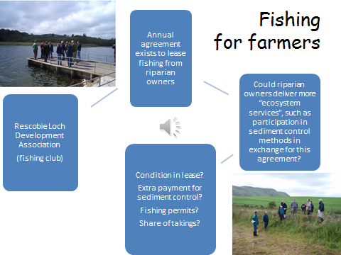

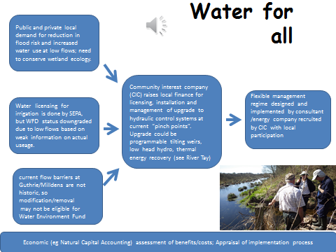

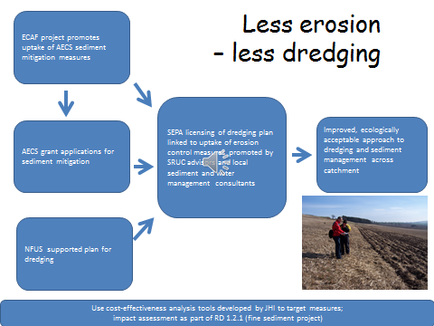

Figure 1. Schematics of potential PES schemes in the Lunan Water

References
Scottish Natural Heritage. An Evaluation Framework for applying the Ecosystem Approach. http://www.snh.gov.uk/docs/A2045565.pdf
Vinten, A.J.A. Draft proposal for installation of flexible hydraulic control through a tilting weir at outlet to Balgavies Loch, Lunan Water catchment, Angus.

Draft proposal for installation of flexible hydraulic control through
a tilting weir at outlet to Balgavies Loch, Lunan Water catchment, Angus.

A.J.A.Vinten, James Hutton Institute

- Introduction
The Scottish Government (RESAS) have been funding JHI to undertake strategic water research about the impact of measures to mitigate diffuse pollution and improve water management in the Lunan Water over the last 10 years. This has included monitoring of water quality and water levels and regular stakeholder engagement through annual Lunan science update meetings. These have shown that water management to mitigate floods and droughts is a major concern in the catchment, and the events of last winter (Storm Frank) have confirmed the need to address flooding concerns.
Janice Corrigan of Angus Council contacted JHI this spring (2016) for information about water level recording in the catchment. We provided information to her, and also suggested a meeting to further discuss ideas that we presented at the World Water Congress in Edinburgh last year, about introduction of flexible hydraulic controls to provide water management benefits across a range of stakeholders and water conditions. In this work we presented evidence of an upward trend in water levels in the Lochs (Figure 1). Since then, we have won funding for a new round of RESAS strategic research work, to explore the potential for using Payments for Ecosystem Services approaches to deliver improved water management in the catchment and elsewhere. One of the projects we proposed (WATER FOR ALL) was to carry out “action research” to explore the technical and socio-ecological aspects of introducing hydraulic controls in the Lunan Water.

- Hydraulics background.
A farmer in the catchment (John Compton, West Mains of Turin - now deceased) carried out a survey of the bed levels and water levels in the region downstream of Balgavies Loch in the 1980’s. These are summarised in Figure 2 (after updating to metric units), along with some more recent measurements and estimates. Water level recordings by JHI over the last two years are summarised in Figure 3.
In area A, at the outlet from Balgavies Loch, the water flows across a lip (elevation 59.1m) through a culvert of approximately 3.5m diameter for 50m before flowing into a common, near level channel for a mill lade and the Lunan Water. On 11 July 2016 we estimated the discharge to be ca. 120 l/s with a water level of 59.3m.
In area B, the spillway of the common lade into Chapel Mires, a former spillway allowing water to fall from the common channel/lade into the course of the Lunan Water has been shored up, but slightly further upstream there is a spillage of water over the edge of the lade into the Chapel Mires and Lunan Water. This spillage occurs at an estimated water level of >59.1m, through a channel about 2.6m. On 11 July 2016, with water level of 59.3m the estimated discharge through this spillway was 100 L/s. Stage-based flow estimation will be subject to variation as flow occurs through soft, unconsolidated channel bank.
In area C, the Milldens Weir system, the Balgavies Burn (discharge data available) runs into the common lade bringing significant water and bed load of gravel and cobble sized mineral material and woody debris. Downstream of this are a spillway and two weir gates. The estimated flow though these two gates was ca. 80 L/s on July 11 2016. The weir gates have a base slightly above the stream bed base of 59.0m, and are about 0.9m wide. These manually operated gates deliver water:
(1) to the North (or Milldens) Lade, and thence to Milldens water mill, some 500m downstream and to adjacent fields, when irrigated;
(2) as return flow to the Lunan Water. The Lunan Water, at the time of J. Compton’s measurements was about 0.7m below the level of water in the North Lade;
The gates may be set open or closed depending on the needs of the owner, as well as catchment requirements (they are normally open, but closed for some periods according to demand for irrigation water in the fields adjacent to the North Lade or when the Mill is being run). On 11 July 2016 we estimate that about 15% of the flow was going to the North Lade (fully open) and 85% to the return flow to the river (a submerged rectangular orifice of 8cm width had been set).
A spillway is present, for relief at high flows (in use during storm Frank, see Figure 4).
In area D, an area for potential Hydro development, the Mill Lade runs under the old railway line at which point it is over 2m above the level of water in the Lunan Water and could therefore be suitable for a small scale hydro scheme.
Area E, known as chapel mires, is an area of natural flood plain of about 5ha containing species such as cowbane (Cicuta virosa) and Bogbean (Menyanthes trifoliata) which are either nationally or locally scarce and declining. It receives water from the Common Lade and the Lunan Water at high water levels and releases water to the Lunan Water at low water levels. Quadrats to identify plant species present were taken in this area in May and July 2016 (Figure 5).
We are not currently in a position to model the hydraulics of this system in detail, but we have monitored water levels in Rescobie Loch, Balgavies Loch inflow and upstream of Milldens Weir over the last two years (see Figure 3), a period when Balgavies Loch water levels have shown an amplitude of >1.2m, generating upstream and downstream serious flooding (during storm Frank in Dec 2015/Jan 2016) and downstream low flows which could limit abstraction (eg. during May/early June 2016).
Moreover, Water level recording has been done on a fortnightly basis in Balgavies Loch since 2003, and this time series shows increasing minimum and maximum water levels (see Figure 1). The trendline shows a significant, 6.7mm/y upward trend. Annual maxima and minima both also show an upward trend.

- Our outline proposal
Our preliminary thinking is that a tilting weir (eg http://www.aquaticcontrol.co.uk/products/water-flow-control/tilting-weirs), be installed as a 4-year pilot at the site of the spillway for the Milldens weir gates d/s of Balgavies. This would enable a wider range of potential levels than is currently the case and provide remote and multiple user controls. This might help in overcoming technical barriers to holistic water level management in this part of the catchment. There is also a potential for a small hydro scheme (maybe 2-5kW) to feed water, at appropriate times and in the right conditions, from the mill lade back to the river further d/s, which could help to finance weir installation and management.
The structure and controls could be removed at the end of the 5 year research programme (2016-2021) if it did not prove beneficial, and the site re-instated, to ensure ecological integrity of the upstream wetlands is not compromised. We have a number of quadrats installed in the wetlands at which ecological recording (as well as water levels) took place last year, and we plan to revisit on a 2 yearly basis through this current research project. We also have continuing water level monitoring at Balgavies and Milldens Weir (two other sites, at Rescobie Loch and Restenneth Moss, were wiped out by the floods and are currently being restored).
We propose that a ~1m wide tilting weir, with a minimum operational level of ~ 58.5 - 58.8m (to be agreed by stakeholder discussion) be installed at the site of, or next to, the existing spillway at Milldens weir. Costs for control box, weir, bespoke design and installation are of the order of 15-20k.
Benefits for high flow management. By ensuring this new weir gate is open in autumn/early winter to assist lower water levels in the Lochs, the extra range of the tilting weir would provide greater capacity than is currently the case for water storage in Balgavies Loch during winter storm events, such as those observed last winter (2015/6) during storm Frank, when the current manually-operated gate appears to have been closed till late October 2015. Figure 4 shows the condition of the weir gates and the Balgavies and Milldens culverts during storm Frank.
Keeping a low water level in late summer/early autumn would also help keep P enriched water coming from the lochs in late summer/autumn from entering the mesotrophic wetlands of Chapel Mires (see soluble P (SRP) data in Figure 3).
Benefits for low flow management. At low river flows, operating the weir at a lower level than the current weir gates allow, would help to provide additional flow into the Lunan Water to maintain flows. We estimate * that a 0.10m head of water across a new 1m wide weir would deliver about an additional 29% of the long term Q95 for the whole Lunan Water catchment (Q95 at Kirkton Mill = 195 L/s), providing a significant benefit in protecting the lower Lunan from the impact of the low flows which lead to its WFD downgrading and helping ensure restrictions on abstraction are less likely.

- Potential impacts
The impact of such additional flow would be to generate a downward driver in water levels in Balgavies/Rescobie Lochs (78ha of open water) of about 6 mm per day, in addition to current drivers, assuming the latter remain constant. This is similar to the observed natural mean decline rate in levels over May-June 2016 (Figure 3). The impact of such reduction in levels could be mitigated by closing the weir gate in late spring (March-April) to promote increased storage in the Loch system prior to the low flow period in early summer (May-July) when demand (especially for scab control in potatoes) is at its height. The gate could also be closed for agreed short periods during summer to permit delivery of water to the North Lade at Milldens for the benefit of the current owner, when these fields are in irrigated crops.
Peter McPhail of SNH has commented previously on these ideas, and I append his correspondence with me. We hope by ongoing monitoring of the hydro-ecology of the wetlands, setting a time limit on the research and undertaking reinstatement if needed, and engaging stakeholders in design and management, we can allay concerns of negative impact on ecology. Indeed we think it possible, given the increasing trend in water levels, that a management regime with slightly lower water levels may be beneficial to the retention of mire ecology. Colleagues at Centre for Ecology and Hydrology are co-funded by RESAS for this project, and can help with advice on wetland hydrological requirements.

- Future work
Hydraulic modelling/design and scenario management. The management of such a facility would require analysis of the hydraulics and detailed analysis of impact on the water flows and water levels at times critical for flooding, ecology and low flows, as well as with respect to climatic trends. We are working at learning HEC-RAS, a freeware 1D model, but we hope SEPA hydrology, with their inhouse knowledge and availability of hydraulic modelling competence, may be able to collaborate with us in assessing (a) feasibility (b) optimum design (c) performance, over the first phase of the project. If they can make comment at this stage, that would be very helpful.
Payments for Ecosystem Services(PES). Apart from the hydro-ecological aspects of research, we are also interested in the idea of developing community based funding and management approaches (eg. so called Payment for Ecosystem Services) and would like to undertake social science research about this during phase 2, once the technical feasibility has been established (phase 1). This would include research on how to implement a locally acceptable and holistic scheme for management – eg through a community interest company or other PES type approach.
Other sites for such measures. If this pilot were to prove technically feasible and helpful, it might be possible to promote introduction of such controls at two other sites - upstream of Wemyss where the exit to the Restenneth Moss crosses the railway and at Guthrie Castle where a fixed weir currently controls water levels. The latter is the main barrier to fish migration in the upper Lunan Water at present (see EnviroCentre (2014) report).

* http://irrigation.wsu.edu/Content/Calculators/Water-Measurements/Rectangular-Contracted-Weir.php
EnviroCentre (2014) Lunan Water Catchment Study,Draft Report, prepared for Esk Rivers and Fisheries Trust. http://wwwerftorguk/

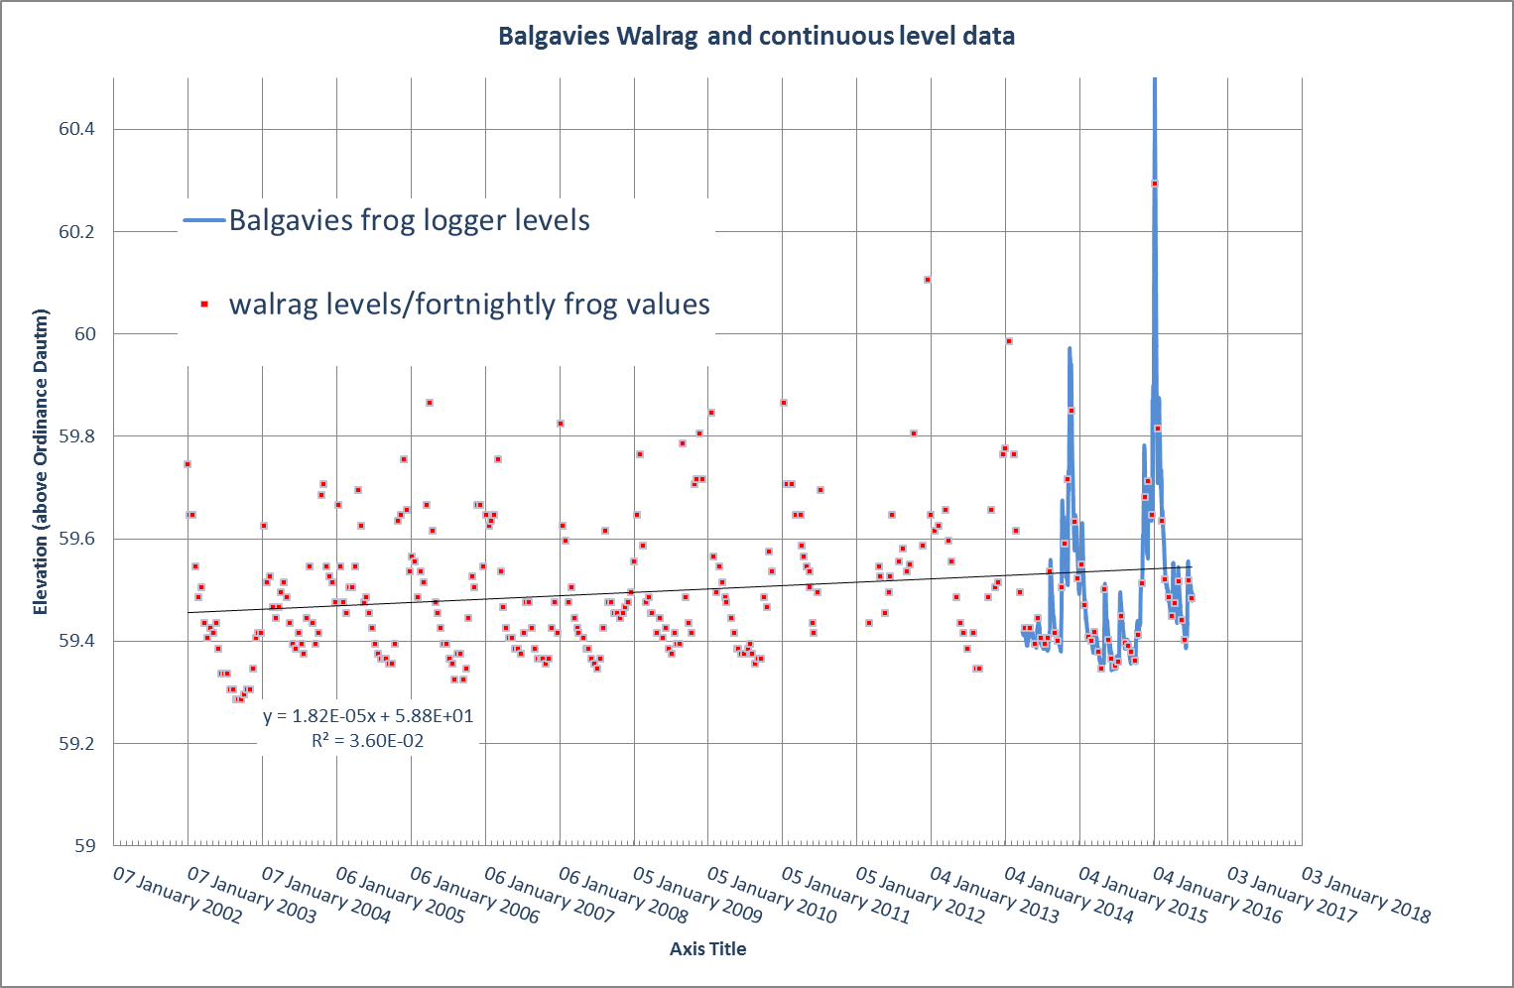
Figure 1. Water levels at Balgavies Loch measured with manual water level recorder (WALRAG) – courtesy of Alban Houghton, Balgavies Reserve, and from 29 March 2014 15min Frog Water Level recordings by JHI. Red squares on Walrag time series from 20 Sept 2014 are fortnightly samples of the Frog logger records.
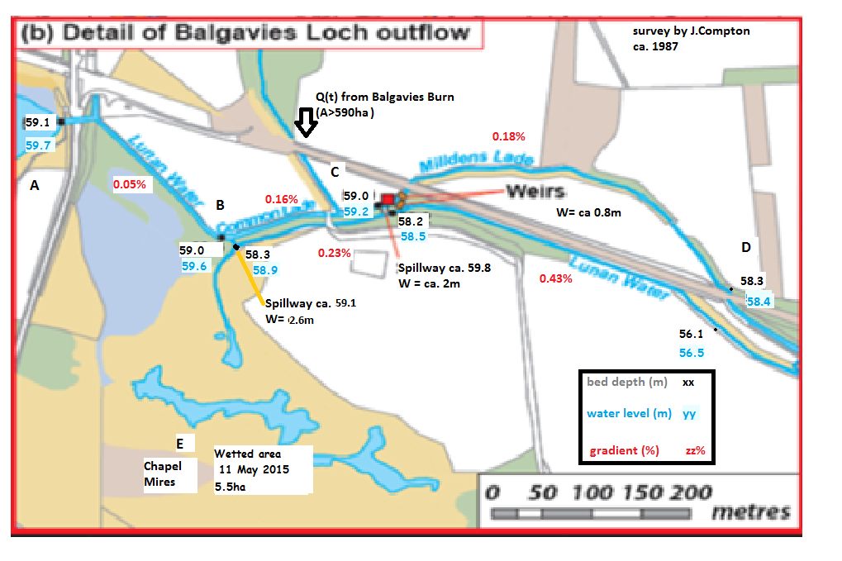
Figure 2. Ordinance datum levels of river and mill lade bed and water surface levels in the area downstream of Balgavies Loch. Main survey taken in the 1980’s (date uncertain). Estimates of extent of chapel mires surface waters and spillway elevations and widths are recent estimates.

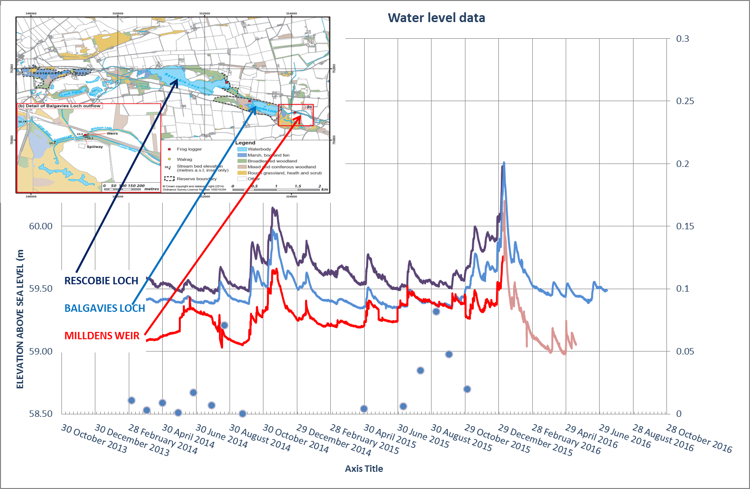
SRP (mg/L
Figure 3. Water levels in Rescobie Loch, Balgavies Loch and at Milldens Weir over the last two years. Note the frog water level loggers installed on Rescobie Loch and Milldens Weir were damaged/lost during Storm frank (Dec/Jan 2015/6). The trace shown for Milldens weir post Jan 2016 is based on a separate (diver) level recorder, which remained intact.Note that the return gate on the weir at Milldens is usually open but sometimes closed during the period. When closed (eg end June – end October 2015), the levels at Milldens Weir approach those of Balgavies Loch and may even exceed them due to discharge from the Balgavies Burn. These gates can also be affected by accumulation of woody debris, increasing the water level in front of the debris “dam”.
Also shown is the Soluble Phosphorus (SRP) concentration in the water, which shows large peaks in late summer due to P release from loch sediments. Keeping this water out of Chapel Mires, through adaptive control of water levels, might help retain its mesotrophic condition.

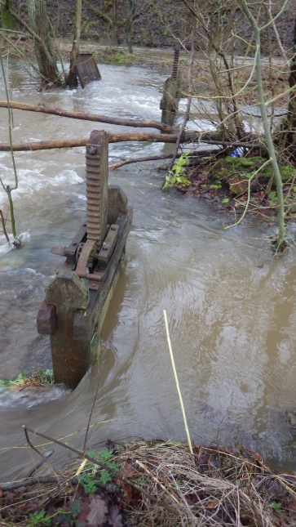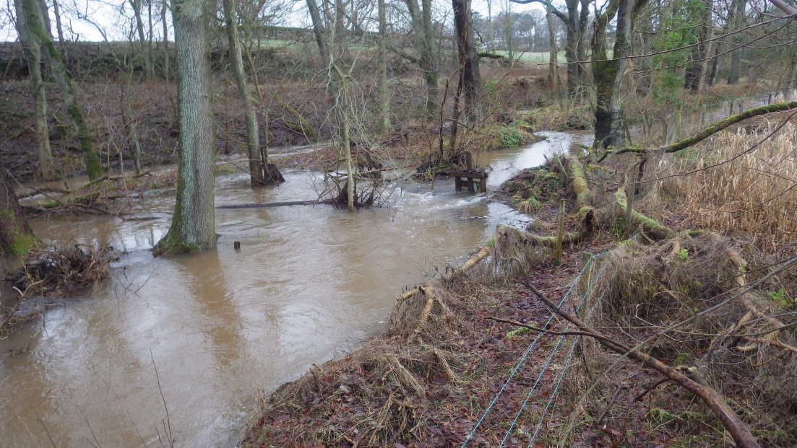
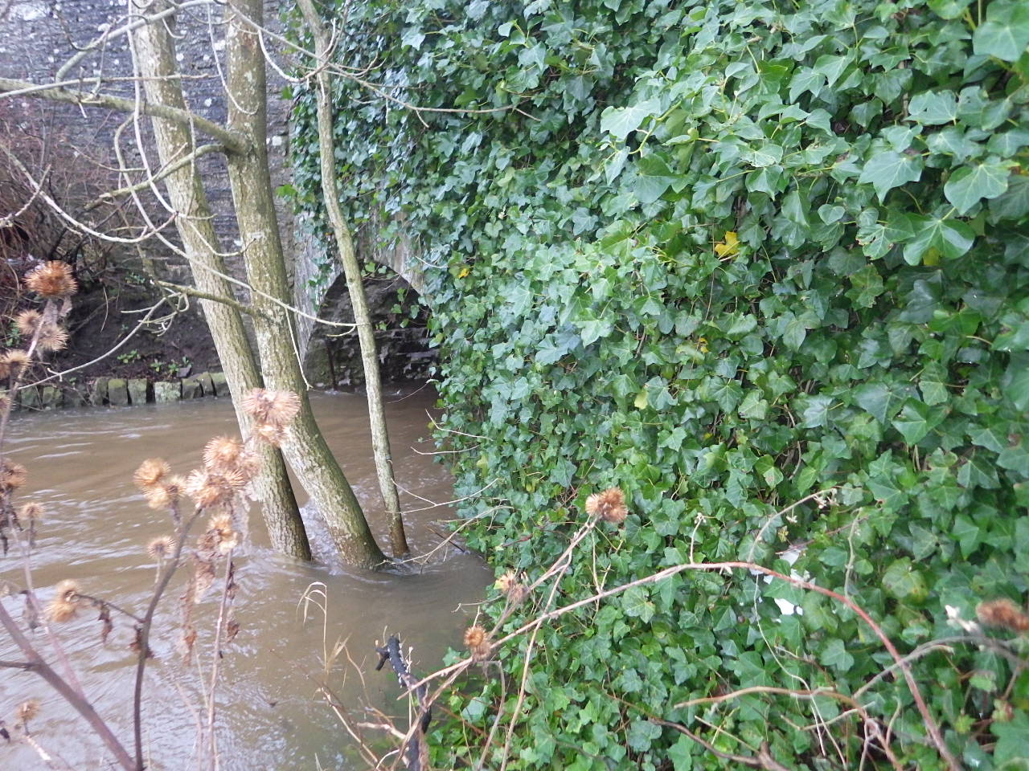
Figure 4. Milldens Weir and Balgavies outlet culvert in aftermath of Storm Frank (8/1/2016).

Figure 5. Ecological quadrat data from Chapel Mires.
MILLDENS Quadrat 1
Corners of quadrat: NO5410350403 and NO5410350405 (2mx4m quadrats)
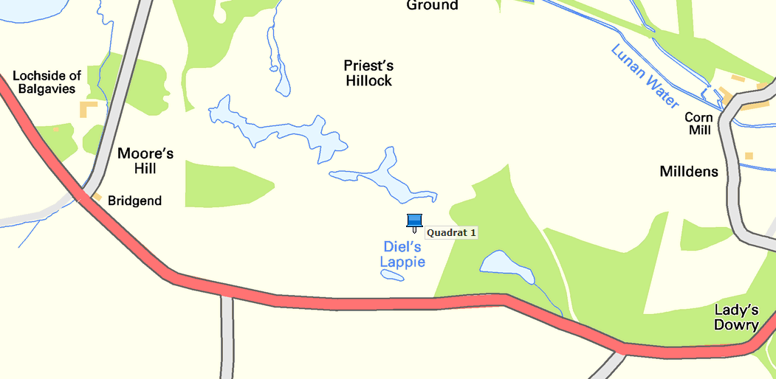
% cover at time of sampling | May | July
Menyanthes trifoliata | 1 | 50
Lysimachia thyrsiflora |  | 20
Cicuta virosa | 3 | 15
Potamogeton polygonifolius | 8 | 10
Iris sp. | 4 | 5
Comarum palustre | <1 | 3
Myrica gale | <1 | 1
Lemna minor | 3 | 1
Epilobium palustre | 2
Juncus articulatus | 1 | <1
Agrostis stolonifera | <1
Carex rostrata | <1 | <1
Carex sp. | <1
Carex disticha |  | <1
Equisetum fluviatile | <1 | <1
Utricularia sp. | <1 | <1
These species indicate a wet habitat with shallow water but which can lack of water for a while.

Quadrat 2
Corners of quadrat: NO5395350420 and NO5395350426 2m x 4m
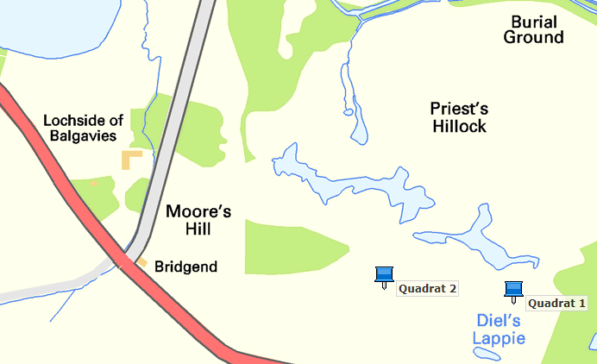
% cover at time of sampling | May | July
Bryophytes cover |  | 75
Iris sp. | 25 | 40
Carex rostrata | 5 | 20
Vascular plant cover |  | 20
Menyanthes trifoliata | <1 | 10
Epilobium palustre | 4 | 10
Litter | 20 | 5
Epilobium ciliatum |  | 4
Cicuta virosa | <1 | 2
Equisetum fluviatile | <1 | 2
Lysimachia thyrsiflora |  | 1
Juncus articulatus | <1 | 1
Myosotis scorpioides |  | 1
Comarum palustre |  | <1
Lemna minor | 1 | <1

Appendix 1. Email correspondence with SNH.
Dear Andy
Thank you for your consultation over the proposed ECAF application for the Lunan Water. There appear to be some positive steps in here, especially in relation to water quality and sediment loads, though we would need further details on any projects that are within or directly adjacent to either of the two SSSIs in the upper catchment of the Lunan Water.
As we explained on our joint site visit on 21 April 2015, given the national importance of the scarce lowland wetland habitat types and species present at Rescobie and Balgavies Lochs SSSI and Restenneth Moss SSSI, we would need to be sure that the installation and subsequent operation regime of the tilting weirs would not have unfavourable implications for the SSSI. For example, we are especially concerned that there are no negative impacts on the Chapel Hill mires from changes to the hydrological regime e.g. from lowering water levels in the summer or raising water levels in the winter. At the present time we are still not clear of the detail of the proposed hydrological regime. I felt it only fair to let you know this was our current thinking given your preparation of an ECAF application.
We will of course look at any data produced as part of the research work you were planning to carry out last year and reassess our position in response to this. Are any assessments or reports based on this work now available? The email refers to a map but this was not attached to the email we received. Is it possible to get a copy of this?
Regards
Peter McPhail
Operations Officer
Scottish Natural Heritage, Tayside & Grampian
All of nature for all of Scotland
dd. 01738 458595
e. peter.mcphail@snh.gov.uk
m. 07827239253 (infrequently used)
a. Battleby, Redgorton PERTH PH1 3EW

website: www.snh.gov.uk; e-consultations: Tayside_Grampian@snh.gov.uk
From: Andy Vinten [mailto:Andy.Vinten@hutton.ac.uk]
Sent: 14 December 2015 10:19
To: Peter McPhail
Subject: ECAF proposal on Lunan Water
Dear Peter

James Hutton Institute are in a consortium (with Littlewood Land Care and Lockett Agri-Environmental) working on an application to the Scottish Government for a project supported by the Environmental Co-operation Action Fund or ECAF :
https://www.ruralpayments.org/publicsite/futures/topics/all-schemes/environmental-co-operation-action-fund/
Our plans for an ECAF proposal entitled “Sediment and water management in the Lunan catchment“, centre around three main themes and we are currently seeking clarification from the steering group as to the eligibility of each of these for funding:
1. Improvement of water quality in the standing waters at the head of the upper catchment (Rescobie and Balgavies Loch). This would involve use of water quality options from ECAF, focusing on sediment and sediment bound P load reductions, such as sediment retention bunds, wetlands and dual purpose irrigation lagoons. Here we have an established focus group and long term monitoring, of chemistry, discharge and turbidity in the feeder streams.(see map)
2. Reduction of sediment loads in the Vinny Water, as well as reducing diffuse pollution (our chemistry monitoring suggests the Vinny Water soluble P concentrations put it into the Moderate Ecological Status class). These sediment loads also contribute to sediment-related flooding issues and pressure to dredge in the lower catchment (around Inverkeilor).
3. Removal or modifications of barriers to flow and migration. One of the riparian owners is willing to consider modification to a tilting weir, which would enable more active management for multiple benefits to the catchment (low flows in lower catchment, flooding in upper catchment, eutrophication of standing waters and wetlands). Our proposal to install remotely controlled tilting weirs responsive to multi-stakeholder needs, is an attempt to provide a win-win approach to water management. This would delivers some public goods (improvement in low flows, flooding and wetland ecology) while also providing for ongoing amenity use and improved private benefits in terms of improved availability for irrigation, and reduced risk of flooding of private property. We are currently seeking clarification from SEPA (Amber Bush) as to the eligibity of these structures for Water Environment Fund and ECAF funding.
If you are willing, please address the letter to :
Littlewood Landcare/James Hutton Institute/ Lockett Agri-environmental ECAF consortium and send by email to these participants.
If you need further information please feel free to get in touch with me or Carol Littlewood. We hope to have clarification on eligibility for the above 3 themes in the near future.
Best regards
Andy Vinten

Dr Andy Vinten
Managing Catchments and Coasts Theme
James Hutton Institute
tel 0044 0844 9285428
email: andy.vinten@hutton.ac.uk

