**An introduction to web mapping with vector tiles and reflections on improving the sharing and reuse of the James Hutton Institute’s geospatial data**

Kit Macleod, David Donnelly, and David Miller

The James Hutton Institute, UK.

|  |  |
| --- | --- |
|  | The Macaulay Development Trust |

# Executive summary

Increasingly geographic maps are being provided in digital formats via web and mobile applications (apps). Most people in high income countries, like the UK, are familiar with Google Map type apps e.g. using a web map app when searching for directions or somewhere to visit. The focus of this report is on innovations in the provision and use of vector maps, specifically vector tiles, in web maps.

This report was funded by the Macaulay Development Trust (MDT) as part of the ‘Demonstrating potential scientific and societal Impact from innovations in Vector tile data and digital tools for web/mobile Apps (DIVA)’ seedcorn project. Vector tiles and related technologies and tools are based around a relatively new spatial data format that is transforming the provision and use of vector spatial data. Specifically, this report focuses on four objectives: review and summarise developments in vector tile technologies to aid researchers and stakeholders use geospatial information for natural resource management (Objective 1); share these summaries with researchers and MDT-relevant stakeholders, including web pages (Objective 2); explore and demonstrate how existing research geospatial datasets could be provided as vector tiles (Objective 3), and plan how the James Hutton Institute can use vector tile technology to improve delivery of natural resource data to users (Objective 6).

In this report we provide an overview of web mapping and vector tile technologies and datasets (Section 2) and explore providing Hutton’s geospatial data as vector tiles (and related formats), reflect on our experiences, some of the challenges involved, and provide recommendations for further work (Section 3).

The rapid evolution and increased use of vector tiles has been driven by several factors. These include the ability of nearly all web browsers (including Internet Explorer 11) to support WebGL v1 - which is required for rendering of vector tiles. Other reasons include the ability to dynamically style vector maps, including basemaps; their smaller data size compared to raster tiles; and the ability to create interactive geospatial data-driven apps e.g. MapBox’s early vector tile apps (since 2013) and Esri’s Smart Mapping (since 2016).

We explored the use of vector tiles for two main groups of Hutton geospatial datasets, covering large parts of Scotland, that a range of individuals and organisations use. Currently, Hutton’s main geospatial datasets are provided as shapefiles and web mapping services which can easily be discovered and viewed using either SpatialData.gov.scot Metadata Portal, Scotland’s Environment map, or the related Scotland’s Soils site. Our efforts were focussed on Esri’s and Mapbox’s tools and technologies. Esri’s tools are widely used by Hutton colleagues and across Scottish Government’s agencies e.g. SEPA and NatureScot. We also explored Mapbox’s tools and technologies, since they have been at the forefront of innovations in 2D and 2.5D vector tiles over the past 10 years. Over the space of four months we held several group discussion sessions combined with individual exploration of the Esri and Mapbox tools and technologies with a focus on Hutton’s geospatial datasets.

We explored and identified solutions for two of the greatest challenges in providing vector tiles (or any web map): how to present a user with information on large numbers of classes and how to present complicated/patterned symbology.

Contents

Executive summary 2

1. Introduction, purpose, and audience 4

1.1 Introduction to web maps and vector tiles 4

1.2 Purpose of this report and audience 4

2. Overview of the evolution of vector tiles and related web mapping technologies 5

2.1 Web mapping technologies and vector tiles 6

2.2 Evolution of web mapping standards for 2D, 2.5D, and 3D vector tiles 8

2.3 Providers of vector tile basemaps 9

3. Planning how users of Hutton geospatial datasets could benefit from vector tiles 10

3.1 Current provision of geospatial data 10

3.2 Exploring provision of Hutton’s geospatial datasets as vector tiles 12

3.2.1 Geospatial datasets and their associated challenges and potential solutions 12

3.2.2 Reflections on our use of vector tile tools and technologies 12

3.3 Recommendations for future work 13

Acknowledgements 14

Reference 14

Appendices 15

Appendix 1: Vector tile two-minute introduction 15

Appendix 2: Creating and using a custom patterned symbology 16

# 1. Introduction, purpose, and audience

## 1.1 Introduction to web maps and vector tiles

Increasingly geographic maps are being provided in digital formats via web and mobile applications (apps). Most people in high income countries, like the UK, are familiar with Google Map type apps e.g. using a web map app when searching for directions or somewhere to visit. Since the launch of Google Maps in 2005 a wide range of features and capabilities have been added, for example see this summary by the Vice President of Engineering at Google Maps[1]. Traditionally, digital geographic maps are provided either in a vector or raster format. Vector maps provide points e.g. monitoring locations, lines e.g. a river network, and/or polygons (enclosed areas) e.g. a woodland. Whereas raster maps are like digital photographs (made up of large numbers of pixels, with numerical or other values associated with each pixel). The focus of this report is on innovations in the provision and use of vector maps, specifically vector tiles, in web maps. Online introductions to web mapping include this blog post from Esri[2]. A one-page summary of vector tiles can be found in Appendix 1 covering what are vector tiles and why they may be of use to you. If you are interested in learning the basic principles of map design (including what is a map and types of maps), this is a useful short guide[3].

## 1.2 Purpose of this report and audience

This report was funded by the Macaulay Development Trust (MDT) as part of the ‘**Demonstrating potential scientific and societal Impact from innovations in Vector tile data and digital tools for web/mobile Apps** (DIVA)’ seedcorn project. Where vector tiles[4] and related technologies and tools are based around a relatively new spatial data format that is transforming the provision and use of vector spatial data. Specifically, this report focuses on four objectives: review and summarise developments in vector tile technologies to aid researchers and stakeholders use geospatial information for natural resource management (Objective 1); share these summaries with researchers and MDT-relevant stakeholders, including web pages (Objective 2); explore and demonstrate how existing research geospatial datasets could be provided as vector tiles (Objective 3); and plan how the James Hutton Institute can use vector tile technology to improve delivery of natural resource data to users (Objective 6). These objectives are linked, for example our learning about vector tile tools and technologies has informed our thinking and planning for how the James Hutton Institute (hereafter referred to as Hutton) could use these tools and technologies to improve delivery of its geospatial data.

The audience of this report includes Hutton colleagues (researchers and senior management team) who are interested in learning more about innovations in web mapping and vector tiles, and how their projects could benefit from using vector tiles to improve the display of geospatial data. The intended audience also includes colleagues from a wide range of natural resource management organisations involved in the provision of geospatial datasets who may be interested to learn more about web mapping and vector tile technologies and their potential use.

In this report we provide an overview of web mapping and vector tile technologies and datasets (Section 2) and then explore providing Hutton’s geospatial data as vector tiles (and related formats), reflect on our experiences, some of the challenges involved, and provide recommendations for further work (Section 3). This report was written during the autumn of 2020, and due to the rapidly evolving nature of vector tile technologies and tools and their use, aspects of this report may already be out of date. However, we have recently reached a point where vector tile functionality is now available across all web, mobile and desktop GIS/geospatial data science platforms - therefore the writing of this report is timely.

# 2. Overview of the evolution of vector tiles and related web mapping technologies

The rapid evolution and increased use of vector tiles has been driven by several factors. These include the ability of nearly all web browsers (including Internet Explorer 11) to support WebGL[5] v1 - which is required for rendering[6] of vector tiles. Other reasons include the ability to dynamically style vector maps, including basemaps, as presented in this Esri story map about customising their vector basemaps[7]; their smaller data size compared to raster tiles; and the ability to create interactive geospatial data-driven apps e.g. MapBox’s early vector tile apps (2013)[8] and Esri’s Smart Mapping (2016)[9]. Vector tile mapping availability and functionality has increased in part due to updates to Esri’s ArcGIS JavaScript API 4.0 (2016)[10] and desktop ArcGIS Pro (2016)[11], and more recently native support in desktop QGIS (2020)[12]. If you are interested to learn more about web mapping, then Veenendaal et al. (2017) provided an academic review of changes in web mapping.

|  |  |
| --- | --- |
|  |  |

Figure 1. Demonstrating how symbology can change as you zoom into a map using Ordnance Survey’s Open Zoomstack vector tiles.

As mentioned above, one of the main reasons why vector tiles have become widely used is the ability to change the symbology as you zoom into and out of a map. This is demonstrated using the Ordnance Survey’s Open Zoomstack vector tiles[13] - as you zoom into (level 17) the woodland symbology transitions from a flat/solid green to include a tree sprite (image). This can be achieved using vector tile styling tools, as demonstrated below (Figure 2). This link[14] takes you through the steps to update the style of a vector tile layer using the Change Style button in the Esri Map viewer. And here is an example from Esri on automating changes to a vector basemap[15].

Figure 2. Demonstrating the Esri tool for changing vector tile styling.

## 2.1 Web mapping technologies and vector tiles

Web mapping tools and technologies as their name suggests are primarily for producing maps accessed through a web browser on a range of devices. This report focusses on web mapping. If you are interested in creating web mapping apps that can also be installed on Android and iOS (Apple) mobile phones (without having separate code bases), then we suggest you explore the Ionic framework[16] or Apache Cordova[17]; we would recommend Ionic, over Cordova, as Adobe recently ended their investment in Apache Cordova (and PhoneGap framework)[18]. We are not covering producing native Android or iOS geospatial apps here. Often you will need to use desktop software like Esri’s ArcGIS[19], QGIS[20], or R’s relevant packages to create vector tiles. For example, here is a blog post about working with vector tiles in QGIS[21].

Table 1. A list of web mapping ‘Quick start’ pages.

|  |
| --- |
| Leaflet  https://leafletjs.com/examples/quick-start/ |
| OpenLayers  https://openlayers.org/en/latest/doc/quickstart.html |
| Esri  https://developers.arcgis.com/javascript/latest/guide/quick-start/ |
| Mapbox  https://docs.mapbox.com/mapbox-gl-js/api/ |
| Cesium  https://cesium.com/docs/tutorials/quick-start/ |

To use an existing vector tile resource for web mapping you will need to use some specific software depending on what you know and prefer to use and what you are trying to achieve. For example, if you are trying to get a simple interactive (or static) web map on a web page then you may choose to use Esri’s free (for non-revenue-generating apps[22]) but not open source ArcGIS API for JavaScript[23] or if you are looking for a free and open source option, you may choose to start with the Leaflet JavaScript library[24]. If you are an R user, then you may want to avoid standard web development technologies and tools (which use JavaScript and CSS) then you can use the Shiny package, from RStudio, to build interactive web apps[25] or even blogdown[26].

Sometimes it is useful to see how widely a JavaScript library is used, especially if it is free and open source, as this can provide an indication of the level of community support. Figure 3 shows changes in weekly downloads of several JavaScript web mapping libraries over time; you can see that Mapbox-gl and Leaflet are the most widely used (based on downloads from Node Package Manager (NPM)), this does not take account of the use of Content Delivery Network (CDN)/hosted versions like this Esri example[27], and certain communities e.g. Esri’s may make greater use of CDN/hosted versions.

The main providers of web mapping software provide useful ‘Quick start’ pages (Table 1). These ‘Quick start’ pages show you how to create a web page, sometimes this involves adding a vector tile basemap and then other layers of data. Esri refer to these other layers as Feature layers[28], if you are interested in learning more then have a look at the Esri[29] or Mapbox[30] tutorials. In these ‘Quick start’ examples you will see there is a need to access relevant JavaScript and Cascading Style Sheet (CSS) files to create a web map. These can be accessed through a link to a CDN[31] or be installed from NPM[32] - the JavaScript package manager.

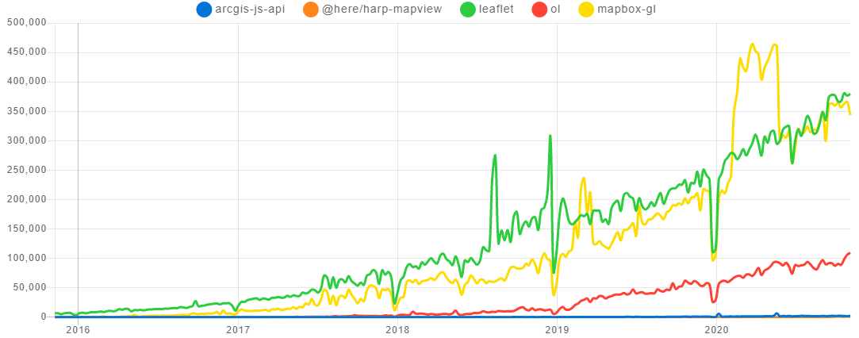

Figure 3. Changes in weekly downloads of several web mapping JavaScript libraries from NPM over the past five years.

## 2.2 Evolution of web mapping standards for 2D, 2.5D, and 3D vector tiles

The ability of web mapping software to show vector tiles (or other data type) with height information e.g. topography or building heights is often referred to as 2.5D, compared to the ability to show more complicated 3D objects[33]. In 2010, Eric Gundersen started Mapbox to build and share better tools to support data-driven decision-making. Mapbox started to provide vector tiles and Mapbox Studio to style them to users[34]. Then in 2014, Mapbox released the Mapbox Vector Tile Specification[35], which was rapidly adopted (in the absence of any relevant international standards) including by Esri in 2015[36]. Since 2011, the founders of Cesium[37] have been advancing the provision of 3D tiles. In 2015, they shared a specification for streaming large 3D geospatial datasets[38]. Earlier in 2020 they released a summary of the main concepts in 3D tiles[39]. Where, 3D Tiles are designed for streaming and rendering massive 3D geospatial content such as photogrammetry, 3D buildings, and point clouds e.g. LiDAR. Cesium and the Open Geospatial Consortium 3D tile specification provides a detailed overview of 3D Tiles[40].

The Open Geospatial Consortium (OGC)[41] is an international consortium of businesses, government agencies, research organisations, and universities with the mission to make geospatial (location) information more Findable, Accessible, Interoperable, and Reusable (FAIR) through geospatial standards. The OGC completed the second phase of its Vector Tiles Pilot[42] in April 2020. Its objective was to deliver a consistent, interoperable online/offline architecture for vector tiles based on feature and tile servers, and GeoPackage. The first phase of the Vector Tiles Pilot[43], developed Vector Tile extensions for the OGC API - Features specification (formerly named Web Feature Service 3.0), Web Map Tile Service (WMTS) and GeoPackage, as well as a conceptual model for tiled feature data. This built on earlier work, for example the 2000 release of the Web Map Server (WMS) specification that standardised the way in which Web clients requested maps[44]. Recently, the OGC have announced they are continuing to work on a successor to WMTS that allows for Application Programming Interfaces (APIs) to serve any tiled resource over the Web (vector and raster/image)[45].

Table 2. Summary of key vector tile basemap suppliers for web apps

|  |  |  |
| --- | --- | --- |
| **Tile provider** | **Licensing** | **Format** |
| Ordnance Survey Zoomstack1 | Open Government Licence | GeoPackage, Vector Tiles (MBTiles), and Vector Tile API |
| Esri2 | Esri’s Master License Agreement | Via APIs e.g. for JavaScript |
| Mapbox3 | Unclear (uses OSM and proprietary data) | Vector Tiles (MBTiles) and APIs |
| Google4 | Google Maps Platform License Agreement | API |
| Tilezen5 | ? | API |
| HERE6 | ? | API |
| OpenMapTiles7 | BSD + CC-BY | MBTiles or API |

1- <https://www.ordnancesurvey.co.uk/business-government/products/open-zoomstack>

2-https://www.arcgis.com/home/group.html?id=30de8da907d240a0bccd5ad3ff25ef4a#overview

3-https://docs.mapbox.com/vector-tiles/reference/

4- https://developers.google.com/maps/documentation/javascript/vector-map

5-<https://www.nextzen.org/>

6-<https://developer.here.com/documentation/examples/maps-js/maps/map-at-specified-location>

7-https://openmaptiles.com/

## 2.3 Providers of vector tile basemaps

There are a range of providers of vector tiles from free OpenStreetMap vector tiles from OpenMapTiles to other commercial companies (Table 2). Several companies are competing in the area of ‘location intelligence’ including HERE, Mapbox, Google, and Esri (Table 2). This link provides a 2020 business assessment of their relative strengths[46]. One of the largest uses of these spatial technologies is the automotive industry. The UK Ordnance Survey released free vector tile data (Zoomstack) last year. An overview of the main providers of vector tile base maps is provided (Table 2).

Table 3. Current provision of Hutton’s geospatial datasets.

|  |  |
| --- | --- |
| **Dataset** | **Available formats** |
| **Local to national soil datasets** |  |
| 1:250,000 National Soil Map | Shapefile and Web Mapping Service (WMS) |
| 1:25,000 Soil Map of Scotland (partial cover)  A phased release of the corrected digital data started in 2014 and will continue into 2021. | Shapefile and WMS  <https://spatialdata.gov.scot/geonetwork/srv/eng/catalog.search;jsessionid=D14412449D5A34AEF9F9C39AE95E89C0#/metadata/9b16b1cb-ed65-4864-a360-43fa7f038500> |
| **Land related datasets** |  |
| Land Cover of Scotland (LCS88) | Shapefile |
| 1:250,000 Land Capability for Agriculture (LCA) national cover | Shapefile and WMS  <https://spatialdata.gov.scot/geonetwork/srv/eng/catalog.search;jsessionid=D14412449D5A34AEF9F9C39AE95E89C0#/metadata/3088a01e-13b2-41e0-98e3-0d771a05e9f6> |
| 1:50,000 Land Capability for Agriculture (LCA) partial cover | Shapefile and WMS  <https://spatialdata.gov.scot/geonetwork/srv/eng/catalog.search;jsessionid=D14412449D5A34AEF9F9C39AE95E89C0#/metadata/cfa70edc-8884-433d-b1f3-3970f5b4b047> |
| 1:250,000 Land Capability for Forestry (LCA) national cover | Shapefile and WMS |
| Available Water Capacity, Scotland WMS  1:250 000 soil map unit | Shapefile and WMS  https://spatialdata.gov.scot/geonetwork/srv/eng/catalog.search;jsessionid=D14412449D5A34AEF9F9C39AE95E89C0#/metadata/71e38c05-cf6c-4732-b966-7c202e146cc4 |
| **Other geospatial datasets** | Available via the SEFARI Natural Asset Register Data Portal[47] |

# 3. Planning how users of Hutton geospatial datasets could benefit from vector tiles

In this section we set out how Hutton’s geospatial datasets are currently provided (Section 3.1). Then explore and identify solutions for two of the greatest challenges in providing vector tiles (or any web map) (Section 3.2).

## 3.1 Current provision of geospatial data

The two main groups of Hutton geospatial datasets, covering large parts of Scotland, that a range of people and organisations use are soil related[48] and land related for example the Land Cover of Scotland (LCS88)[49] and Land Capability for Agriculture (LCA)[50] datasets. There are other datasets for specific projects and sites, for example the Centre for Sustainable Cropping Platform, which is focussed on the Balruddery Farm near Dundee[51]. Currently, these geospatial datasets are provided as Esri Shapefiles and as Web Mapping Services from Scotland’s SpatialData.gov.scot Metadata Portal[52] , from a Hutton soil data page[53], and the SEFARI Natural Asset Register Data Portal[54] (Table 3).

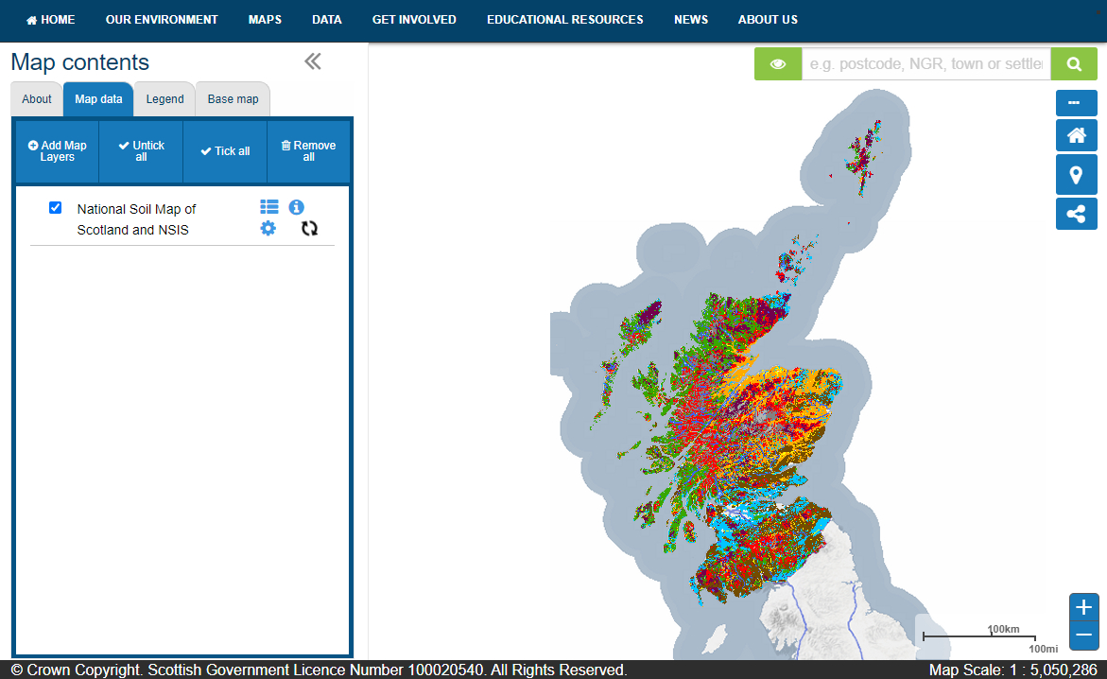

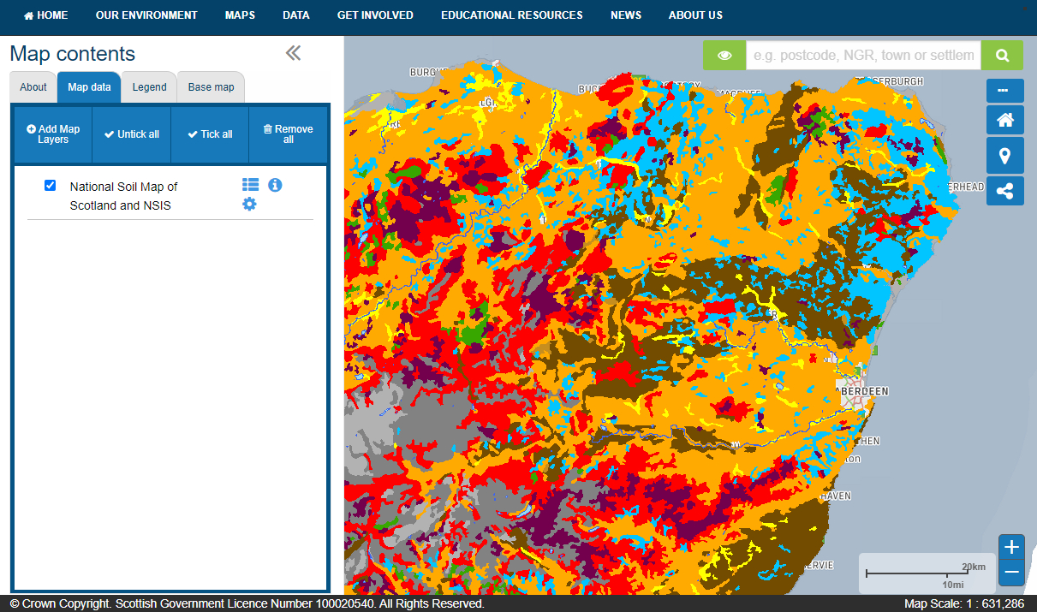Figure 4. Using Scotland’s environment map to view the national soil map as a web mapping service.

Hutton’s main geospatial datasets are provided as shapefiles and web mapping services which can be easily discovered and viewed using either SpatialData.gov.scot Metadata Portal[55] or Scotland’s Environment map[56]. When you use Scotland’s Environment map (or the sister site Scotland’s Soils[57]) and add a new ‘map data layer’ soil data (National Soil Map of Scotland and NSIS), your computer sends a request to the Hutton ArcGIS server web map service which returns a set of images (PNG format) for the spatial extent in the map viewer. As you zoom in and out (using the +/- buttons) then each time your computer makes another request for another more/less detailed set of images for that spatial extent (Figure 4). To ensure rapid display on the user’s device for the more commonly used datasets these images are generated in advance and stored on the Hutton servers. Each of these caches of images requires in the region of 1 Gb of storage space or more on the server. The images for the less often used datasets are generated on demand on the server.

## 3.2 Exploring provision of Hutton’s geospatial datasets as vector tiles

This section provides an overview of our exploration of vector tiles and related technologies to improve the delivery of Hutton’s geospatial data. This informed our suggestions for further work (Section 3.3). Our efforts were focussed on Esri’s and Mapbox’s tools and technologies, since Esri’s are widely used by Hutton colleagues and across Scottish Government’s agencies e.g. SEPA and NatureScot. We also explored Mapbox’s tools and technologies, since they have been at the forefront of innovations in 2D and 2.5D vector tiles over the past 10 years. Over the period of four months we held several group discussion sessions combined with individual exploration of the Esri and Mapbox tools and technologies with a focus on Hutton’s geospatial datasets.

### 3.2.1 Geospatial datasets and their associated challenges and potential solutions

We chose three representative datasets, the National Soil Map (Scotland), Land Cover of Scotland (LCS88), and Land Capability for Agriculture (LCA), since they are widely used and each pose particular challenges to being provided as vector tiles. The main challenges the National Soil Map (Scotland) posed were due to its 500 classes. Specifically, how do you provide a digital symbology (i.e. how to visually represent these different classes) for this number of classes and then how do you make this information available on a digital device that has a limited screen size (compared to a large paper map). On the excellent Scotland’s Soils site page for the National soil map of Scotland, you can view the soils based on 10 high level classes[58]. The LCS88 dataset also has many classes and may require complicated e.g. patterned symbols as well as plain solid (also called flat) colours. Whereas the LCA dataset on Scotland’s Soils site has 14 classes[59].

### 3.2.2 Reflections on our use of vector tile tools and technologies

Esri provide useful guidance on how to create vector tiles using ArcGIS Pro[60]. Once vector tiles have been created, then you can use a graphical interface for the restyling of the tiles. Mapbox provide an easy to use service to create a set of vector tiles (see pricing[61]). Then using Mapbox Studio the tileset (their name for a set of vector tiles[62]) can be styled.

The two greatest challenges (Section 3.2.1) for providing vector tiles (or any web map) are how to present a user with information on large numbers of classes and how to present complicated/patterned symbology.

#### 3.2.2.1 Presenting large numbers of classes

In terms of web maps on large screens (desktop or laptop) or small screens (mobile phone) then there are several ways we could present a dataset/map with a large number of classes. Design choices include considering if there is a need for a legend, this 2008 advice from a senior Esri cartographer said “whenever possible, it is desirable to eliminate the need for a legend altogether if you can manage to have the map carry the information”[63]. For example, with a popup[64] (visual object displaying information from one or more layers in a map) information from a layer can be provided as demonstrated in this ‘Intro to popups’ [65]. This other example shows how custom content can be created in a popup including the ability to search a dataset/map layer[66]. If a legend is required then there are several options, for example the style of the legend can be set to ‘card’ that enables a legend to take up less space and be scrolled horizontally[67], as demonstrated in this example[68]. Another straightforward option[69] is to use the MapView properties (i.e. how wide is the display) and this can control the size of the legend and if it is shown at all. In addition. the Esri web mapping tools include a facility to collapse or expand legends and other tools into smaller clickable icons.

#### 3.2.2.2 Presenting patterned symbology for classes

In our experimenting with Esri and Mapbox vector tile creation with patterned symbology, we found it was possible to create these using both Esri and Mapbox software. Details of this work are provided in Appendix 2.

One, long standing, cartographic challenge has been the inability to convert an existing symbology created for one set of software to another, for example converting Esri symbology to QGIS. Recently, geospatial consultants North Road have made their SLYR tool available to all users as a QGIS plugin[70]. The SLYR tool supports automatically converting MXD, MXT and PMF documents to QGIS projects.

## 3.3 Recommendations for future work

In this section we provide a set of recommendations that could be undertaken as ‘underpinning’ activities in a future Strategic Research Programme.

**General web mapping**

Hutton’s geospatial data could be cached (a copy is made) on a widely used Content Delivery Network (CDN’s), for example Amazon CloudFront[71] which would involve a cost, to reduce any lags (latency) in a user pressing a button and viewing an image. Here is an example from a community contributor (i.e. not a member of Esri staff) on how they added static files to edge locations using Amazon's CDN Service (CloudFront) to distribute static ArcGIS Enterprise files across the globe, allowing for quicker load times and less load on the back-end server[72].

Hutton needs to explore increasing its use of ArcGIS Online for providing geospatial data and enabling Hutton staff a richer interface for creating web maps and for other organisations to access our datasets with improved performance e.g. faster display and functionality e.g. restyling layers. This Esri video demonstrates some of the advantages of using ArcGIS Online[73]. Before greater use was recommended to Hutton colleagues, we need to clarify the status of the credits in the online account (currently a BBSRC account).

Hutton could explore how it showcases its geospatial data through web pages and directs users to access these resources. Consideration of existing geospatial data portals like SEWeb and its daughter site Scotland’s Soils and their plans, to ensure we were making it easier for Hutton’s geospatial data to be findable, accessible, interoperable, and reusable.

**Vector tile specific**

Hutton could explore and utilise advances in 2D and 2.5D/3D web mapping. There is a need to make it easier for staff to create web maps using their preferred software. Carrying out research involving web maps and communicating our research using web maps is going to increase. Making colleagues aware of the potential of using Esri, Mapbox, Leaflet, and Cesium JavaScript APIs is important, as well as easy to use tools/sites like Observable[74]

# Acknowledgements

This work was funded by the Macaulay Development Trust.

# Reference

Veenendaal, B., Brovelli, M. A., and S. Li,. (2017). Review of web mapping: Eras, trends and directions. ISPRS International Journal of Geo-Information, 6(10), 317.

# Appendices

## Appendix 1: Vector tile two-minute introduction

**Why might you be interested in vector tiles?** Your work involves data with a location attribute i.e. geospatial data. You are interested in geospatial data representing specific features on the Earth’s surface; vector data include points e.g. monitoring locations, lines e.g. a river network, and/or polygons (enclosed areas) e.g. a woodland. You use desktop GIS software e.g. Esri’s, or free and open-source alternatives e.g. QGIS to store and analyse geospatial data, you may manipulate geospatial data using programming languages like Python or R, and/or you may be interested in the production and use of web/mobile apps that use geospatial data. You may already be familiar (or even be expert) in the use and creation of vector tiles. You may not even realise that you have been using vector tiles in your Esri GIS basemaps (a layer with geographic information that provides the context for additional layers) or on web/mobile apps you use.

**What are vector tiles and why might they be of use to you?** Vector tiles are increasingly being used to provide vector data. They are popular for delivering styled web maps, as they have smaller data requirements than raster (image) tiles and they can easily be customised e.g. you can change the colour of a feature. As you zoom into a map on an app (with vector tiles), then layers of tiles are added with different levels of detail e.g. finer representation of boundaries (illustrated in Figure 1).

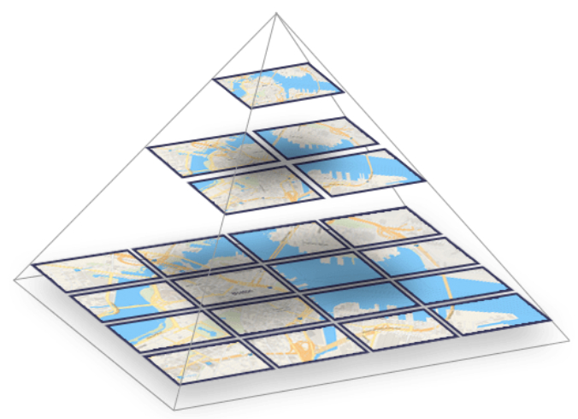Figure 1. Vector tiles for different zoom levels (image from Maptiler[75])

MapBox[76] have been creating and using vector tiles for about ten years, more recently they became available in Esri’s JavaScript API 4.0[77] and related Smart Mapping (2016)[78], in desktop ArcGIS Pro (2016)[79], and are now natively supported in desktop QGIS (2020)[80]. The UK Ordnance Survey (OS) trialled vector tiles in 2018 and released their OS Open Zoomstack[81] product in 2019.

**Here are examples of vector tile use cases:** Esri ArcGIS Pro (or ArcGIS online) and are interested in vector basemaps[82] and/or creating vector tile packages[83]; you use QGIS desktop GIS software[84]; and/or you are involved in developing web/mobile apps using basemaps from providers including Esri[85] and Mapbox[86], use tools to style vector tiles e.g. Mapbox Studio[87], and/or are interested in how to use them[88].

## Appendix 2: Creating and using a custom patterned symbology

This is a visual summary of exploring how a custom patterned symbology could be created and added to Mabox. Mapbox uses scalable vector graphics[89] files to allow users to define their own custom symbols. These SVG files can be created easily using the free to use Inkscape[90] software. In Mapbox it is possible to introduce a degree of opacity and offset to the pattern created from the SVG image graphic but the ability to display symbols randomly distributed within a polygon seems to be unavailable (or at least not readily apparent). As with Esri tools, creating a repeating pattern that doesn’t adversely affect the overall appearance of the map is a challenge. To add the SVG-based pattern to a Mapbox style we duplicated an existing symbolised map layer and added a pattern based on a filter on an attribute (in this case one of the LCA codes).

We created a SVG with a frame at 50 px and added a couple of trees at different sizes. This can be quickly done in Inkscape by copying and pasting the graphical symbol and rescaling by dragging one of the symbol anchor points. A map showing this pattern of three trees in the light green area and the grid of single larger trees (with the widened spacing) in the dark green areas is shown below.

The map below shows an earlier version with the denser tree symbols prior to enlarging the SVG frame to introduce more spacing (in dark green) and the blue area containing the symbol with the modified spacing.

We then added the layer to ArcGIS Pro (using the WMTS option[91]) but either ArcGIS Pro or Mapbox is rescaling the symbols and the appearance is poor as shown below. It is possible that this could be remedied with greater knowledge and experience in using these tools.

Using the instructions provided by Mapbox we added this layer to an ArcGIS online map. Here is a screen shot from that map.

This testing using Mapbox has produced a tolerably good result. However closer inspection discovered artefacts around almost every polygon where part of the tree symbol can be found outside the polygon they should be in. Further modifications of the SVG would possibly fix that problem, perhaps by including more space around the tree feature. However, it can also be noted that the spacing between the trees is good in this example.

1. https://blog.google/products/maps/look-back-15-years-mapping-world/
2. https://www.esri.com/arcgis-blog/products/product/uncategorized/web-mapping-101/
3. <https://www.axismaps.com/guide/>
4. https://en.wikipedia.org/wiki/Vector_tiles
5. https://www.khronos.org/webgl/
6. https://wiki.openstreetmap.org/wiki/Rendering
7. https://www.arcgis.com/apps/Cascade/index.html?appid=a74a8b251f6141fa9561041d36ea56e3
8. https://blog.mapbox.com/vector-tiles-for-mapbox-streets-71d2b607e89c
9. https://www.esri.com/arcgis-blog/products/arcgis-online/mapping/how-to-smart-map-in-3-easy-steps/
10. https://www.esri.com/arcgis-blog/products/announcements/announcements/its-here-arcgis-api-for-javascript-4-0-released/
11. https://www.esri.com/arcgis-blog/products/mapping/mapping/vector-tiles-preview/
12. https://www.lutraconsulting.co.uk/crowdfunding/vectortile-qgis/
13. https://www.ordnancesurvey.co.uk/business-government/products/open-zoomstack
14. https://enterprise.arcgis.com/en/portal/latest/use/update-vector-tile-style.htm
15. https://support.esri.com/en/technical-article/000016718
16. https://ionicframework.com/
17. https://cordova.apache.org/
18. https://phonegap.com/
19. https://www.esri.com/en-us/arcgis/products/index
20. https://qgis.org/en/site/
21. https://www.lutraconsulting.co.uk/blog/2020/06/10/vectortiles-part1/
22. https://developers.arcgis.com/pricing/
23. https://developers.arcgis.com/javascript/
24. https://leafletjs.com/
25. https://shiny.rstudio.com/
26. https://bookdown.org/yihui/blogdown/
27. https://developers.arcgis.com/javascript/latest/guide/get-api/
28. https://doc.arcgis.com/en/arcgis-online/reference/feature-layers.htm
29. https://developers.arcgis.com/labs/
30. https://docs.mapbox.com/help/tutorials/
31. https://www.cloudflare.com/en-gb/learning/cdn/what-is-a-cdn/
32. https://www.npmjs.com/
33. https://stackoverflow.com/questions/59732285/what-is-the-difference-between-mapbox-gl-js-and-cesium.
34. https://blog.mapbox.com/vector-tiles-for-mapbox-streets-71d2b607e89c
35. https://github.com/mapbox/vector-tile-spec
36. https://blog.mapbox.com/mapbox-vector-tile-specification-adopted-by-esri-14138105872f
37. https://cesium.com/index.html
38. <https://github.com/CesiumGS/3d-tiles>
39. <https://github.com/CesiumGS/3d-tiles/blob/master/3d-tiles-overview.pdf>
40. <https://www.ogc.org/standards/3DTiles>
41. https://www.ogc.org/about
42. <https://www.ogc.org/projects/initiatives/vtp2>
43. <https://www.ogc.org/projects/initiatives/vt-pilot-2018>
44. https://www.ogc.org/ogc/historylong
45. https://www.ogc.org/blog/3233
46. https://www.here.com/omdia-2020-platform-report?form_id=1426&form_category=analyst-report&detailed_source=www.here.com%2Fomdia-2020-platform-report
47. http://nar.hutton.ac.uk/
48. https://www.hutton.ac.uk/learning/soilshutton/soil-data-and-maps
49. https://www.hutton.ac.uk/learning/exploringscotland/landcover-scotland-1988
50. https://www.hutton.ac.uk/learning/natural-resource-datasets/landcover/land-capability-agriculture
51. http://csc.hutton.ac.uk/
52. https://spatialdata.gov.scot/geonetwork/srv/eng/catalog.search#/home
53. <https://www.hutton.ac.uk/learning/natural-resource-datasets/soilshutton/soils-maps-scotland/download>
54. http://nar.hutton.ac.uk/
55. https://spatialdata.gov.scot/geonetwork/srv/eng/catalog.search#/home
56. https://map.environment.gov.scot/sewebmap/
57. https://soils.environment.gov.scot/
58. https://soils.environment.gov.scot/maps/soil-maps/national-soil-map-of-scotland/
59. https://soils.environment.gov.scot/maps/capability-maps/land-capability-for-agriculture-partial-cover/
60. <https://doc.arcgis.com/en/arcgis-online/manage-data/publish-vector-tiles.htm>
61. https://www.mapbox.com/pricing/
62. <https://docs.mapbox.com/help/how-mapbox-works/>
63. https://www.esri.com/arcgis-blog/products/product/mapping/cartographic-design-legends/
64. https://developers.arcgis.com/javascript/latest/api-reference/esri-views-View.html#popup
65. https://developers.arcgis.com/javascript/latest/sample-code/intro-popup/index.html
66. <https://developers.arcgis.com/javascript/latest/sample-code/popup-customcontent/index.html>
67. https://developers.arcgis.com/javascript/latest/api-reference/esri-widgets-Legend.html#style
68. https://developers.arcgis.com/javascript/latest/sample-code/widgets-legend-card/index.html
69. https://developers.arcgis.com/javascript/latest/sample-code/view-breakpoints-css/index.html
70. https://north-road.com/2020/08/05/announcing-slyr-community-edition/
71. https://aws.amazon.com/cloudfront/
72. https://community.esri.com/t5/implementing-arcgis-blog/a-content-delivery-network-cdn-approach-to-arcgis-enterprise/ba-p/886922
73. https://www.youtube.com/watch?v=0XI-J8XUNeU&t=5s
74. https://observablehq.com/
75. https://www.maptiler.com/news/2019/02/what-are-vector-tiles-and-why-you-should-care/
76. https://docs.mapbox.com/vector-tiles/reference/
77. https://www.esri.com/arcgis-blog/products/announcements/announcements/its-here-arcgis-api-for-javascript-4-0-released/
78. https://www.esri.com/arcgis-blog/products/arcgis-online/mapping/how-to-smart-map-in-3-easy-steps/
79. https://www.esri.com/arcgis-blog/products/mapping/mapping/vector-tiles-preview/
80. https://www.lutraconsulting.co.uk/crowdfunding/vectortile-qgis/
81. https://www.ordnancesurvey.co.uk/business-government/products/open-zoomstack
82. https://www.esri.com/arcgis-blog/?s=#&tag=vector-basemaps
83. https://pro.arcgis.com/en/pro-app/help/sharing/overview/vector-tile-package.htm
84. https://www.lutraconsulting.co.uk/blog/2020/06/10/vectortiles-part1/
85. https://www.arcgis.com/home/group.html?id=30de8da907d240a0bccd5ad3ff25ef4a&view=list&showFilters=true#content
86. https://docs.mapbox.com/vector-tiles/reference/
87. https://www.mapbox.com/mapbox-studio/
88. <https://developers.arcgis.com/javascript/latest/guide/create-a-starter-app/>
89. https://en.wikipedia.org/wiki/Scalable_Vector_Graphics#:~:text=Scalable%20Vector%20Graphics%20(SVG)%20is,Consortium%20(W3C)%20since%201999.
90. https://inkscape.org/
91. https://desktop.arcgis.com/en/arcmap/10.3/map/web-maps-and-services/adding-wmts-services.htm