Soil Maps of Scotland (partial cover)
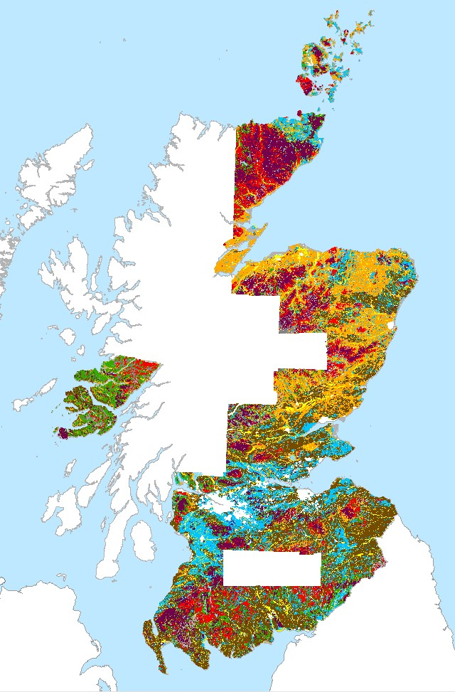
Tags
Soil, Scotland

Summary
This is the large scale Soils of Scotland data and it covers the main cultivated areas of Scotland and also parts of the upland areas within the extent of the published 1:63,360 soil map series. Its formal title is "Soil Maps of Scotland (partial cover)"

Description
This is the digital dataset which was created by digitising the Soils of Scotland 1:25,000 Soil maps and the Soils of Scotland 1:25,000 Dyeline Masters. The Soils of Scotland 1:25,000 Soil maps were the source documents for the production of the Soils of Scotland 1:63,360 and 1:50,000 published colour map series. The soil map units are based on Soil Associations, Soil Series and Phases which reflect parent material, major soil group, and major soil sub-groups, drainage and (for phases), texture, stoniness, land use, rockiness, topography and organic matter. Phases are not always mapped. In general terms this dataset primarily covers the cultivated land of Scotland but also includes some adjacent upland areas and the Island of Mull and the Ardnamurchan peninsula. While all of the available source documents for this map series have been digitised, additional areas mapped at higher resolution for specific purposes have not been digitised. Should there be a requirement for other areas to be captured, the Internal Contact should be contacted in the first instance. Attribute definitions: The attributes on each map (coverage) are specific to that map sheet, but in general terms the following categories are mapped: soil association, soil series, parent material, soil complexes, soil phases, skeletal soils, alluvial soils, organic soils, miscellaneous soils, mixed bottom land, built-up area, quarries/disturbed ground, collieries/bings, golf courses.
Lineage
Data gathering: Start: 1947, End: 2022
Collection methods: A source document was chosen. The order of preference was dyeline master, clean copy, compilation then working draft. The document was overlayed with a piece of matte plastic on which the details of the source were recorded, registration marks were drawn and three tablet reference points were indicated. An overlap of 1-2mm was drawn if there was no suitable line on the base map. The map was then compared with its neighbours and the detail drawn into the overlap area which avoided underlap problems later. A check was made of the coding across sheets. Problems with line placement or coding were noted on a query sheet. The soil lines were digitised following the centre of the line and continuing into the overlap area. Stream digitising was not used. Nodes were snapped where two or more lines met at a point. The line file was cloned to make the point file, to ensure that the geo-referencing was the same in both files and the lines were then deleted from the point file. Rubber-sheeting points were digitised at every grid intersection on the base map, i.e. every 1km intersection. Rubber-sheeting points were given the code of 1. Soil codes are shown on the 1:63,360 map as letters indicating soil association and soil series. These letter codes were translated to the five digit numbers (seven where soil phases were mapped) used in the Oracle table Soils of Scotland Soil Series Codes (4100001001). A single point was digitised within each polygon and the appropriate five or seven digit code assigned to it. A plot was made, checked against the original and any discrepancies noted. Queries were noted on the query sheet and passed with the map to a soil surveyor to be resolved. Once all the edits had been completed a final plot was made and passed to another member of the digitising team, for a final check. Files were made which would be acceptable to ARC/Info. Coverages were generated, rubber-sheeted, and the rubber-sheeting points removed. Clipped with LCS88 coastline and lochs and finally edge-matched to its neighbours.
Originator: Formerly DAFS (Department of Agriculture and Fisheries for Scotland), then SOAEFD (Scottish Office Agriculture, Environment and Fisheries Department), then SERAD (Scottish Executive Rural Affairs Department), now RESAS (Rural and Environment Science and Analytical Services division).
Data collectors: SURVEYING: John S Bell, John S Bibby, Eric L Birse, Cyril J Bown, Colin GB Campbell, J Cruickshank, DT Davies, HG Dion, Frank T Dry, NA Duncan, Donald W Futty, James H Gauld, Robert Glentworth, CJ Grant, Robert Grant, PC Harper, R Hart, David J Henderson, Rodney EF Heslop, J Andrew Hipkin, Gordon Hudson, JI Jack, WD Jardine, RA Jarvis, Donald Laing, DM Lang, RD Law, E Lawrence, Allan Lilly, JM Mackay, RC Mackenzie, J Menzies, DW Merrilees, BD Mitchell, RJF Morris, John W Muir, MJ Mulcahy, Andrew J Nolan, GE Orbell, JM Ragg, James S Robertson, J Charles C Romans, Brian M Shipley, J Smith, JH Stevens, WR Strachan, William Towers, Alexander D Walker, Gary G Wright. DIGITISING: Jaik Campbell, Susan MacLeay, Sandy Moir, Ruth A Morrison, David Tulett, David Donnelly, Grant Campbell, Keith Marshall, Hans Hengelaar, Sian Broome. QUERY CHECKING: John S Bell, Andrew J Nolan. LEGEND COMPILATION: Allan Lilly, Gordon Hudson.
This data set has received a phased revision. The digitising of the recently added data was funded by the Rural & Environment Science & Analytical Services Division of the Scottish Government.
This version is the first to include the whole of the Partial Coverage data (corresponding to the extent of the published 1:63,360 soil maps) and it completes the digitising programme. The newly added data in this release includes digitising of the Mull and Ardnamurchan & Morven 1:63,360 maps and it also completes the following maps which were partially digitised in previous versions: Black Isle, Nairn & Cromarty, Banchory, Blairgowrie, Crieff and Stirling. The area of newly digitised data is approximately 4,000 km2. This version is being released on 27th July 2022.
Phase Eight included data for part of Sutherland and completed the county of Caithness. Phase Eight was released on 4th August 2021.
Phase Seven included data for the Orkney Islands and it was released on 3rd September 2020.
Phase Six was released on 2nd April 2019. This release continues within Version 9 but adopts the suffix Phase 6 to show continuity with previous phases. Phase 6 includes an additional 1,637 km2 in the north and 1,682 km2 in the south. Additional areas will be digitised between 2019 and 2021 and made available. In the southern area (corresponding to sheets NY48/49/58/59) as no large scale published soils maps have been created, the soils data relating to these maps was collected largely at a reconnaissance level for the 1:250,000 scale soil survey and was enhanced by interpretation of aerial photograph imagery.
Phase Five was the first revision in the Version 9 of the data (first released in 2018), and it superseded Phases One, Two, Three & Four of Version 8 of the data. It was released on 9th March 2018. This includes all the data previously issued. That version did not include the information on which parts of the data were edited under each phase as it was intended to represent a stable version of the data, the detailed information on each phase is available on request. Additional areas will be digitised between 2018 and 2021 and made available. This release (Phase 5) included a substantial additional area of data (3,374 km2) in the south-west of Scotland. This has been digitised from unpublished draft maps and manuscripts kept in the Hutton map archive.
The attribute table for Phase 3 revision incorporated new column names compared to previous releases of this data which fit within the naming protocol for soil attributes within Scotland’s National Soils Database and made significant progress towards a seamless integration of datasets.
Phase 4 release included previously unreleased data in Angus and the south-west of Scotland to ensure that the NVZ area updated in 2015/16 was covered by soils data at this scale. A section of the data north of Nithsdale being at smaller scale (less detailed) than the dataset as a whole, has been removed.
In Phase 4 release there was some minor reclassifications of soil series for some of the map units including map units with moundy topography and peat in the intervening hollows, particularly classifying the peat as either confined or semi-confined. Additional information on the constituent soils of some soil complexes has been added. Major soil subgroup code on ‘0.0.0’ has been added where there is no information available to classify the soils. This mainly affects a few small soil complexes.
Phase 3 release included modifications to Strichen and Arkaig Associations as described below:
Strichen and Arkaig Associations
Prior to the completion of the 1:250 000 scale national soil map, soils developed from schists were allocated to the Strichen Association, however, during the national scale mapping, this Association was divided into two based on the stratigraphic age of the Schist (Moine or Dalradian) giving rise to the Arkaig Association (Moine Schists). The extent of these two Associations followed the geological mapping and some soils previously allocated to the Strichen Association were reclassified as belonging to the Arkaig Association. Subsequent revisions of the geological map have relocated the boundary between the Moine and Dalradian Schist such that the soils reallocated to the Arkaig Association are in areas now mapped as Dalradian Schists by geologists. During the revisions of the 1:25 000 and 1:63 360 scale soil maps, it was decided to revert to the soil Association to which the soils in this area were allocated originally, thus the areas allocated to either the Strichen or Arkaig associations on the more detailed maps will differ from the national scale map.
Strichen and Arkaig Associations update
In the period between revisions of the Moine/Dalradian schist boundary by geologists, new soil map units were created which now would be mapped as a different Association. To maintain some continuity with the published map, these map units retain the allocated soil series name with additional text ‘[Strichen variant]’ or ‘[Arkaig variant]’ to denaote if the soil is derived primarily from Dalradian of Moine schist. The published soil map of Mull had the Association as Strichen (Moine) and this has been renamed as Arkiag Association in this digital dataset.
Additional revisions:
In previous versions of the digital dataset, the individual soil types in some complex map units were designated with the association name, a five-digit code ending in ‘00’ and labelled as ‘Unnamed Series’. This presents issues when linking the spatial dataset to an attribute dataset as the soil names are non-unique. Where the unnamed series does have an existing equivalent soil type, it was allocated a series name. Where there is no recognised series name, a name was created by combining the soil association name with an abbreviated version of the major soil subgroup and allocating a unique five-digit code. This follows the same procedure as used in the 1:250 000 scale National Soil Map of Scotland.
Soil drainage categories
As the soil mapping evolved over a period of time, there was a realisation that Peaty gleyed podzols would be better described as poorly or very poorly drained above the iron pan as opposed to the current free or imperfectly drained below the iron pan. Some soils were allocated the drainage category of Poorly drained above the iron pan but the majority of these soils retain the latter designation. As the soil classification makes it clear that these soils are indeed waterlogged in the layers above the pan for at least part of the year (hence the term ‘gleyed’), it was felt that the existing description of the drainage category should remain. Those described as poorly drained above the pan were retained within the digital dataset to keep continuity with the published maps but are essentially the same as those described a freely drained below the pan.
Ownership of this data set was passed to the James Hutton Institute on 1st April 2011.

Credits
Soil Survey of Scotland Staff (1970-1987). Soil maps of Scotland (partial coverage). Digital version 10 release. James Hutton Institute, Aberdeen. DOI 10.5281/zenodo. 6908156.
Use limitations
This data was produced at a scale of 1:25,000. Smaller scale data is available for the whole of Scotland. This data is issued by The James Hutton Institute under its open data licence, a copy of which must be retained with the data. If clarification is required please contact one of those named in this metadata. This data may be used for commercial purposes under the terms of the Hutton Open Data licence. Please contact one of those named in this metadata for further information.

